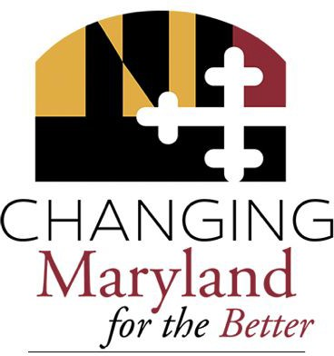

2020 Final Report of the Task Force on Reconciliation
and Equity Maryland SB 350
Larry Hogan
Governor

Boyd K. Rutherford
Lt. Governor
Submitted by:
The Institute for Urban Research Morgan State University

TABLE OF CONTENTS.

Acknowledgements | 1.
Members of the Task Force | 2.
Executive Summary | 8.
Introduction | 7.
Background | 10.
An Overview of General Demographic Trends in the State of Maryland | 12.
A Brief History of Racism in Maryland | 24.
Health and Health Care Disparities in Maryland | 33.
Law Enforcement and Racism in Maryland: Data and Recommendations | 64.
Appendix A: Reconciliation and Equity Virtual Hearing Report. | 75.

ACKNOWLEDGEMENTS.

We would like to acknowledge Sen. Shirley Nathan-Pulliam, whose Bill 350 (co-sponsored by Senators Joanne Benson, James Brochin, Joan Carter Conway, Ulysses Currie, Brian Feldman, William Ferguson and Guy Guzzone) created the Task Force on Reconciliation and Equity (TFRE).

We would also like to acknowledge Sen. Melony Griffith and Del. Regina Boyce, who agreed to support the TFRE as members of the Maryland General Assembly, upon Sen. Nathan-Pulliam’s retirement.

We also acknowledge and thank TFRE members, those on TFRE Sub-Committees, and those citizens and residents who gave their time and talents through participation in TFRE meetings.

Maryland will progress only as far as its most vulnerable citizen. Structural barriers erected because of racism, or any other “ism”, ultimately undermine us all. The ability and willingness to honestly explore the impact of race-based, and other, structural barriers – to address them, dismantle them, and offer repair to those historically and currently, directly and negatively, impacted is not only a justice issue, but an issue of if and how we can and will move forward – together.

MEMBERS OF THE TASK FORCE.

Maryland General Assembly Representatives:
Sen. Shirley Nathan-Pulliam, (former) Maryland General Assembly, Dist. 44, Baltimore City and Baltimore County
Del. Regina T. Boyce, MD General Assembly, Dist.43, Baltimore MD
Sen. Melony Griffith, MD General Assembly President Pro Tempore, Dist. 25, Prince George’s County MD
Del. Edith J. Patterson, Ed.D., Maryland General Assembly, District 28, Charles County MD

Task Force for Reconciliation and Equity Members:
Iman Earl El-Amin, Muslim Community Cultural Center of Baltimore, Baltimore MD
A. Adar Ayira, (formerly) Associated Black Charities, TFRE Co-Chair, Baltimore MD
Noel Brathwaite, PhD., MSPH, MD Department of Health Office of Minority Health and Health Disparities, Baltimore MD
Rabbi Daniel Burg, Beth Am House of the People Synagogue, Baltimore MD
Dr. Raimee Eck, National Cancer Institute, Montgomery County MD
David O. Fakunle, Ph.D., The National Great Blacks in Wax Museum, Baltimore MD
Dr. Marisela Gomez, PhD, MPH, Social Health Concepts, Baltimore MD
Dr. John L. Hudgins, Coppin State University, Baltimore MD
Rev. Florence L. Ledyard, St. Bartholomew Episcopal Church, Baltimore MD

Anisha Thomas, Baltimore Safe Streets, Baltimore MD
Jane Arnold Lincove, Ph.D. University of Maryland, Baltimore County MD
Rev. Kobe Little, Baltimore City NAACP, TFRE former Co-Chair, Baltimore MD
Dayvon Love, Leaders of a Beautiful Struggle, TFRE Co-Chair, Baltimore MD

Annette March-Grier, Roberta’s House, Baltimore MD
Det. Miguel Rodriguez, Baltimore Police Department, Baltimore MD

Brian Smedley, PhD, American Psychological Assn., Washington DC
We also acknowledge and thank Rev. Kobi Little, Baltimore City NAACP, the former Co-Chair of this Task Force.

Task Force for Reconciliation and Equity Subcommittee Chairs:

Education: Jane Arnold Lincove, Ph.D., Chair
Economic Justice: A. Adar Ayira, Chair

Faith Communities: Rev. Florence L. Ledyard, Chair Public Health: Noel Brathwaite, Ph.D., MPH, Chair Public Safety: Det. Miguel Rodriguez, Chair Criminal Justice: Dayvon Love, Chair

Task Force for Reconciliation and Equity Participants:
Haki Ammi, Baltimore City Fire Dept., Baltimore MD Dr. Errol Bolden, Coppin State University, Baltimore MD Kenneth Brown

Derrick Chase, Stand Up Baltimore, Baltimore MD
Kelly Crawford, Morgan State University, Education and Urban Affairs, Baltimore MD

Kamal Cubas, The Bredwinner Group, Inc., Baltimore MD
Dr. Farah Farahati, University of Maryland, Baltimore County MD
Chris Gibbons, MD, MPH, The Greystone Group, Prince George’s County MD
Tamarra Farrow-Stuart, Morgan State University, Baltimore MD

Janaya Hannah, Morgan State University, Baltimore MD

Joshua Harris, NAACP Baltimore City Branch, Baltimore MD Darnell E. Ingram, (formerly) Office of Civil Rights, Baltimore MD Tenequa Jackson, Morgan State University, Baltimore MD
Tykisha Jackson, Morgan State University, Baltimore MD

Rabbi Ariana Katz, Hinenu: The Baltimore Justice Shtiebl, Baltimore MD
Kimberly Lagree-Saleh, Baltimore Police Department, Baltimore MD

Dr. Glenda Lindsey, Morgan State University, Baltimore MD Tiffany Majors, Greater Baltimore Urban League, Baltimore MD David Mann, MD, PhD., Maryland Dept. of Health, Baltimore MD
Mark Martin, PhD, MBA, Maryland Department of Health, Baltimore MD
Tevin Mattison-Graham, Morgan State University, Baltimore MD Cedric McCray, Office of Equity and Civil Rights, Baltimore MD Juan C Nunez, Highlandtown Merchants Association, Baltimore MD Simon Oladele, PhD, Morgan State University, Baltimore MD
Danya Qato, University of Maryland School of Pharmacy and School of Medicine, Baltimore MD

Enrique Ribadeneira, HOLA Baltimore, Baltimore MD
Raul Rivera, Baltimore City Police Department, Baltimore MD

Melvin Russell (Colonel and Chief, Retired), Baltimore City Police Department, Baltimore MD
Evera Rutledge-Smith, Maryland Dept. of Health, Baltimore MD
Dennis A Scott, Baltimore MD

Brian Sims, Maryland Hospital Association, Howard County MD

Brandon Smith, Baltimore City Police Department, Baltimore MD
Dana Vickers Shelly, ACLU, Maryland

James Thomas, Univ. of Maryland College Park, Prince George’s County MD
Muriel Warren, National Collaborative for Health Equity, Washington DC

Francesca Weaks, MS, MCHES, MSU DrPH(C) Morgan State University, Baltimore MD
Michelle Wedderburn, Baltimore MD

John Milton Wesley, Office of Equity and Civil Rights, Baltimore MD

Kellee White, University of Maryland School of Public Health, Prince George’s County MD

Dr. Carlos D. Williams, Robert Wood Johnson Foundation, Princeton, NJ
Dr. Charlotte H. Wood, Coppin State University, Baltimore MD
Jennifer Young, Maryland Department of Legislative Services, Annapolis MD

Morgan State University Institute for Urban Research Staff: Ashraf U. Ahmed, Ph.D., Research Professor
Clement N. Anyadike, Dr. P.H., Research Assistant Professor

Jeff Menzise, Ph.D., Research Associate Professor
Stacey Patton, Ph.D., Research Associate Professor
Glen Robinson, M.A., M.M., Research Assistant Professor
Evelyn Smith, Administrative Assistant
Dr. Raymond A. Winbush, Director and Research Professor

EXECUTIVE SUMMARY.

Over the past several years there has been an increasing level of awareness and willingness to publicly discuss the ways in which structural racism is endemic to the society that we live in. An objective assessment of the data regarding racial disparities in Maryland should result in a deliberate focus on how to deal with structural racism head on. The extent of racial disparities in Maryland is staggering. Structural racism touches many areas of civic life in Maryland, this task force decided that the best use of our time was to narrow our focus and to address health disparities and law enforcement.

The task force thought it was important to produce a report that substantively addressed the history of white supremacy in Maryland in order to highlight the extent of racism in Maryland’s history. It is important that the extent of Maryland’s racist past is highlighted in order underscore the point that the existing disparities are directly connected to centuries of the white supremacist oppression. The racial disparities in Maryland are not the result of mistakes scattered throughout its history, but are the outcome of racial practices, policy, and institutions that resulted in collective material benefits for white people directly derived from the denigration of the humanity of non-white people.

Some readers will find some of the conclusions in this report jarring. Maryland ranks among the worst in the country on issues related to the treatment of Black by the criminal justice system. Black people have been the hardest hit by the Coronavirus pandemic in Maryland, even in communities that do not face the level of socio-economic challenges associated with poverty and lack of access to quality access to healthcare. These are just a couple of the revelations that have emerged over the course of the work of the task force. The task force hopes that this report can advance the work of the Maryland General Assembly being more explicit about dealing with the issue of structural racism and how it relates to the work to be done in the legislature.

INTRODUCTION.
Black residents of the State of Maryland have known for generations that they are being held back by systemic barriers to equity. This report quantifies those barriers in two areas: health and policing. Statistics at the county and state level show the cumulative impact of racial disparity and how the disparate treatment of persons of color occurs incrementally across the entire spectrum of the State’s public health and criminal justice systems. The report’s facts can provide the first step in framing open conversations on exactly where inequalities exist and how best to address them. Its data is drawn from a number of local government agencies and reports. We also considered statements of citizens from various localities throughout the state and considered policy recommendations that would impact the decisions by all stakeholders.

An explicit focus on how current health and criminal justice disparities result from long-standing injustices is needed, along with a racial equity approach when examining community health needs, planning efforts, policies and business decisions that disproportionately impact people of color.

Organizations and lawmakers should consciously analyze laws and their resulting disparities through a racial equity lens with the adoption of racial impact statements which consider whether proposed legislation will have any adverse effects on communities of color relative to whites. We aim to empower stakeholders, community leaders and local residents to forge a more equitable and inclusive future where racial justice is not considered a zero-sum game where the equalization of one community results in the deprivation of rights to others.

BACKGROUND.
Under the co-chairmanship of A. Adar Ayira and Dayvon Love, this report is the culmination of a two-year effort that began in 2019 when the Maryland General Assembly passed Bill 350 entitled Morgan State University Task Force on Reconciliation and Equity. The bill was sponsored by Senator Nathan-Pulliam, Education, Health, and Environmental Affairs Committee and co-sponsored by Senators Joanne Benson, James Brochin, Joan Carter Conway, Ulysses Currie, Brian Feldman, William Ferguson and Guy Guzzone.

The bill required the Institute for Urban Research at Morgan State University (MSU) to convene a task force to explore issues of reconciliation, inclusionary justice, and racial equity that includes specified stakeholders. The task force was required to consult with specified State agencies and local government, as appropriate. The purpose of the task force was to:

- Increase awareness through public discussions about the nature, extent, causes, and consequences of racial inequities;
- Involve individuals and public and private entities, including African American and other minority groups, in every sector throughout the State in a collective process;
- Foster racial equity through recognition, understanding, adjustment, compromise, and repair;
- Recommend strategies, changes, and actions in institutions, policies, and laws to eliminate systemic racism and promote equity, access, and opportunity that can lead to healing and foster reconciliation.

The bill also required the task force to:
  - hold hearings at various locations throughout the State and receive testimony, as specified.
  - study the nature of racism, sexism in the experience of racial inequities, and institutional bias throughout the State;

    - manifestations of institutional and structural racism;
    - the impact of institutional and structural racism, as specified;
    - past and ongoing efforts to promote human rights and social and inclusionary justice; and
    - best practices throughout the United States regarding policies, laws, and systems designed to eliminate institutional and structural racism and sexism and foster repair for those impacted;

  - identify the criteria to be used in monitoring and evaluating the implementation of the strategies and changes in institutions, policies, and laws recommended by the task force;

  - make recommendations regarding strategies, changes, and actions in State institutions, policies, and laws to improve race relations, eliminate institutional and structural racism and gender inequities, and support repair and justice, including specified measures; and
  - monitor and evaluate the implementation of the recommended strategies and changes in State institutions, policies, and laws using the criteria developed by the task force.

This report comes at a time of when national outrage has intensified over the escalating number of unarmed Black people being killed by overzealous police officers across the country. Ongoing protests are being accompanied by urgent national conversations about the need to identify evidence-based solutions to inexhaustible systemic racism. In a short time span we have seen the democratic values of inclusiveness and fairness repeatedly fail Black Americans. Meanwhile, the coronavirus pandemic has compounded the challenges Black people face with higher rates of infection, death, and unemployment.

It is not surprising to find that Black communities are disproportionately affected by Covid-19, in large part because of inequitable environmental and social conditions, decreased access to health care, increased health care costs, and the kind of racial biases directed at patients within the health care system that often drive negative police interactions on the streets. Within and outside of the health care system, the negative impact of stereotyping and discriminatory policies has resulted in poor quality of primary care, increased comorbidities, and decreased quality of life and life expectancy for people of color.

An Overview of General Demographic Trends in the State of Maryland

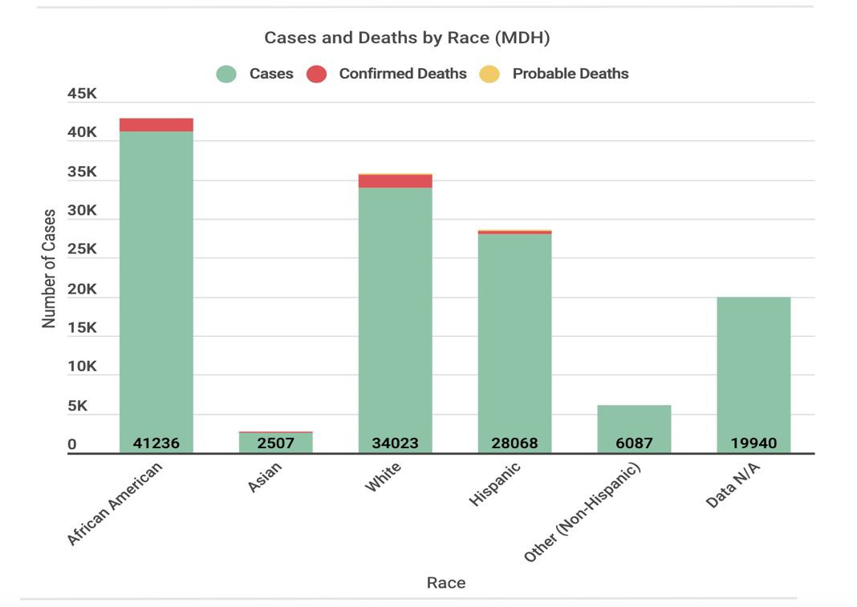
Maryland Coronavirus Cases and Deaths (As of Oct. 12, 2020)
Source: Maryland Department of Health

The stark racial disparities assembled here are part of a long history that have a direct correlation to the legacy of slavery, the turbulent aftermath of Reconstruction, and the development of overtly racist policies and practices that permeated every level of society in the late 19th and early 20th centuries. Due to these devastating government policies that sanctioned racial segregation, today we see large concentrations of poverty in many of Maryland’s communities of color, substandard housing, a circumscribed tax base, segregated and underperforming schools, limited access to good jobs, poor public safety, limited or no access to health foods and health care, poor access to recreational outlets, environmental threats, poor protections in the in the low-wage job market where many Blacks are deemed essential frontline workers, and a generation of young people growing up in neighborhoods where they feel hopeless and demonized.

The negative outcomes you will read about did not emerge in the years this report covers. They are the result of a long historical process that must be acknowledged. To deny this history is to foreclose opportunities for change. These findings can provide the first step in framing an open and relevant conversation on exactly where inequalities in our community exist and how best to address them. This report is not a revelation. It will either test lawmakers’ genuine willingness to devise solutions to dismantle structural racism to create
a more equitable future, or it will be yet another racial disparity report that measures and confirms the power and success of white supremacy.

AN OVERVIEW OF GENERAL DEMOGRAPHIC TRENDS IN THE STATE OF MARYLAND.
Over the last decade, Black Americans have been among the fastest growing population groups in the United States. According to the most recent American Community Survey (ACS), 42 million people who identify as Black or African American make up 12% of the nation’s total population. As the most populous and densely populated states in the country, the current total population of Maryland stands at 6,083,120 people, with Black Americans comprising nearly 30% of the population.

Racial and Ethnic Composition of the State of Maryland

Race or Ethnicity | % of Total Population
White | 56.19%
Black or African American | 29.78%
Hispanic or Latino | 10.4%
Asian | 6.23%
Other Race | 4.16%
Native American | 3.32%
Native Hawaiian or Pacific Islander | 0.05%
Source: Population Division, U.S. Census Bureau, 2020

Maryland’s population of Blacks is the fourth highest in the nation behind Mississippi, Louisiana, and Georgia, and is one of the top five states with the smallest white population in the nation, falling behind Mississippi and Georgia. Maryland is home to one of the wealthiest Black enclaves in the nation, Prince George’s County, which has been hit harder by the coronavirus than any other community in the state. Despite its wealth and educational successes, by July 2020 more than 19,000 of the county’s residents had tested positive for the coronavirus, comprising more than 27 percent of Maryland’s total cases, and nearly 700 had died.

The Baltimore Sun noted that researchers found “that even for those in higher income and educational brackets, simply the stress of navigating a discriminatory world — where doctors don’t take your symptoms as seriously or seeing a police car on your street can be frightening rather than reassuring — takes a toll on health.”¹
The U.S. Census Bureau projected that, by the middle of 2020, nonwhites would account for the majority of the nation’s 74 million children. The share of the country’s non-Hispanic white population began to fall in the mid-20th century. Between 2010 and 2018, the number of white children fell by 2.8 million, or 7.1% while the number of nonwhite children grew by 6.1%. Maryland is among one-third of U.S. states where nonwhite children outnumber all white children under 18.²

Table 1. Total Child Population (ages 0 to 17) By Race and Ethnicity for the State of Maryland, 2010-2019

Race or Ethnicity | 2010 | 2019
American Indian Alaskan  Native | 3,163 | 2,919
Asian | 72,916 | 81,060
Black or African American | 436,224 | 408,541
Hispanic or Latino | 150,200 | 219,986
Native Hawaiian and Other  Pacific Islander | 518 | 635
White | 629,241 | 551,813
Two or More Races | 60,365 | 69,733
Total Child Population | 1,352,627 | 1,334,687
¹ Marbella, Jean and Harris, Naomi. “Maryland’s Prince George’s County is among nation’s wealthiest Black communities, but it leads state in coronavirus cases.” The Baltimore Sun, July 9, 2020.
https://www.baltimoresun.com/coronavirus/bs-md-prince-georges-coronavirus-20200709-pawnopbtgngx7kh6cmq6ugldni-story
.html
² US Census Bureau, National Population Projections, 2017, https://www.census.gov/data/tables/2017/demo/popproj/2017-summary-tables.html; Vespa, Jonathan, Lauren Medina, and David M. Armstrong, “Demographic Turning Points for the United States: Population Projections for 2020 to 2060,” Current Population Reports, P25-1144, U.S. Census Bureau, Washington, DC, 2020. Source: Population Division, U.S. Census Bureau, 2020

Table 2. Top Ten Maryland Cities with Largest Black Populations

Rank | City | Total  Population | Total Black  Population | % Black  Population | % Change In Black  Population Since 2010
1 | District Heights | 5,975 | 5,334 | 89.27% | 2.54%
2 | Glenarden | 6,170 | 5,290 | 85.74% | -4.27%
3 | Bladensburg | 9,397 | 6,316 | 67.21% | 7.69%
4 | New Carrollton | 12,932 | 8,184 | 63.28% | 21.32%
5 | Baltimore | 614,700 | 380,636 | 61.92% | -4.16%
6 | Bowie | 58,368 | 29,966 | 51.34% | 20.45%
7 | Laurel | 25,834 | 12,897 | 49.92% | 11.7%
8 | Cheverly | 6,452 | 3,119 | 48.34% | 0.45%
9 | Greenbelt | 23,203 | 10,866 | 46.83% | -2.09%
10 | Cambridge | 12,401 | 5,770 | 46.52% | 5.08%
Source: U.S. Census, 2014-2018 US Community Survey

Table 3. Total Population Percentage by Race and Ethnicity for All Maryland Counties, 2019

County | Total Population | %  White | %  Black | %  Hispanic or Latino | % Asian | %Native Hawaiian and Other Pacific  Islander | %American Indian or Alaska Native | Two or More Races
Allegany | 14,860 | 88.3 | 8.2 | 1.9 | 1.2 | 0.1 | 0.2 | 2.1
Anne Arundel | 579,234 | 74.2 | 17.9 | 8.1 | 4.2 | 0.1 | 0.4 | 3.2
Baltimore | 827,370 | 60.8 | 29.7 | 5.7 | 6.3 | 0.1 | 0.4 | 2.6
Baltimore City | 593,490 | 30.4 | 62.5 | 5.1 | 2.6 | 0.0 | 0.3 | 2.5
Calvert | 92,525 | 81.3 | 13.1 | 4.1 | 1.9 | 0.1 | 0.5 | 3.1
Caroline | 33,406 | 80.9 | 14.2 | 7.4 | 1.2 | 0.3 | 0.9 | 2.5
Carroll | 168,447 | 91.9 | 3.8 | 3.7 | 2.0 | 0.1 | 0.3 | 1.9
Cecil | 102,855 | 88.5 | 7.2 | 4.6 | 1.5 | 0.1 | 0.4 | 2.4
Charles | 163,257 | 42.8 | 49.0 | 6.0 | 3.4 | 0.1 | 0.8 | 3.9
Dorchester | 162,809 | 66.9 | 29.0 | 5.9 | 1.2 | 0.1 | 0.5 | 2.3
Frederick | 259,547 | 81.2 | 10.4 | 10.2 | 4.8 | 0.1 | 0.5 | 3.0
Garrett | 29,014 | 97.5 | 1.0 | 1.2 | 0.4 | 0.1 | 0.2 | 0.9
Harford | 255,441 | 79.2 | 14.5 | 4.7 | 3.1 | 0.1 | 0.3 | 2.8
Howard | 325,690 | 56.6 | 20.0 | 7.1 | 19.1 | 0.1 | 0.4 | 3.8
Kent | 19,422 | 81.4 | 15.0 | 4.3 | 1.4 | 0.1 | 0.3 | 1.9
Montgomery | 1,050,688 | 60.2 | 19.9 | 19.9 | 15.6 | 0.1 | 0.7 | 3.4

Prince George’s | 864,029 | 24.1 | 64.4 | 19.5 | 4.4 | 0.2 | 1.2 | 2.7
Queen Anne’s | 50,381 | 89.9 | 6.3 | 4.3 | 1.2 | 0.1 | 0.5 | 2.0
Saint Mary’s | 379,894 | 78.1 | 14.9 | 5.6 | 2.9 | 0.1 | 0.5 | 3.6
Somerset | 25,616 | 53.9 | 42.0 | 3.6 | 0.9 | 0.2 | 0.5 | 2.6
Talbot | 37,181 | 83.2 | 12.9 | 6.8 | 1.4 | 0.1 | 0.4 | 1.8
Washington | 151,049 | 82.6 | 12.1 | 5.4 | 1.9 | 0.1 | 0.3 | 3.0
Wicomico | 103,609 | 66.5 | 27.1 | 5.4 | 3.1 | 0.1 | 0.4 | 2.8
Worcester | 52,276 | 83.1 | 13.1 | 3.6 | 1.5 | 0.1 | 0.4 | 1.9

Source: U.S. Census Bureau, 2019 American Community Survey (ACS)

.

Table 4. Total Population Projections for Non-Hispanic White, Non-Hispanic Black, Non-Hispanic Other and Hispanic by Age and Gender for the State of Maryland (January 2018)
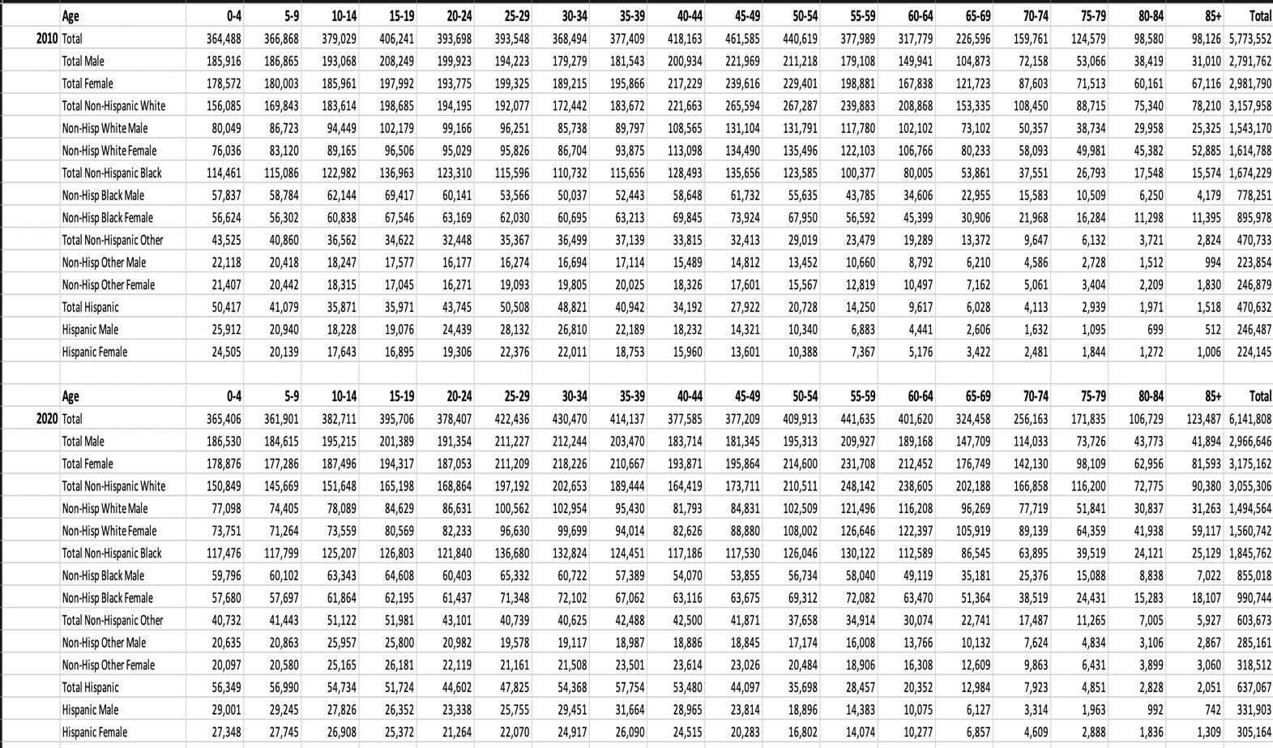

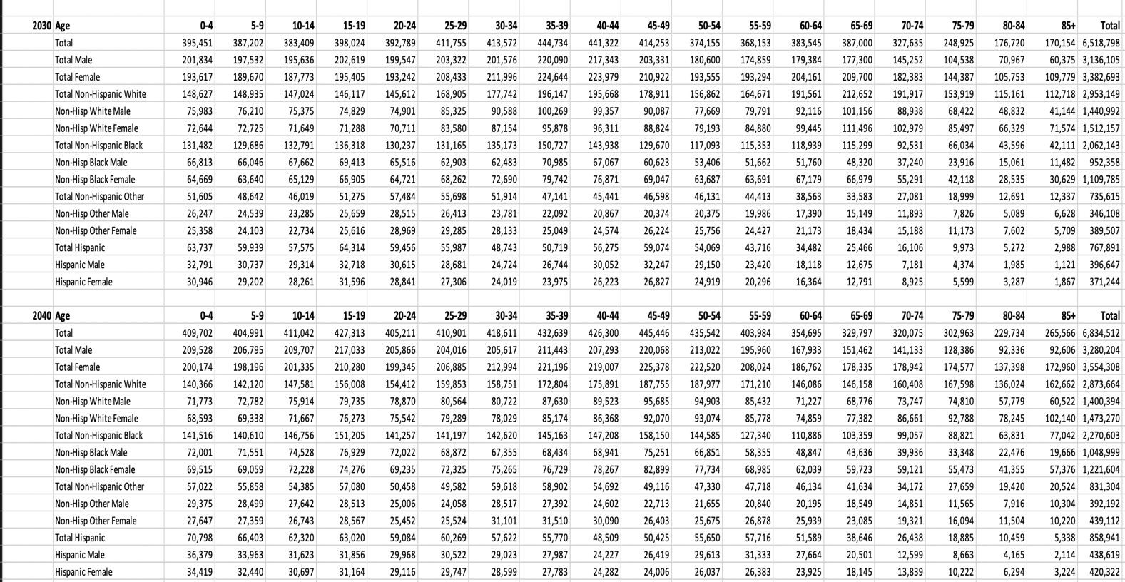
Source: Maryland Department of Planning and State Data Center, 2018

Table 5. Educational Attainment by Race and Ethnicity, 2019

Race or Ethnicity | Total | High School or Higher | BA Degree or Higher
White | 2,385,477 | 92% | 45.5%
Black or African  American | 1,241,353 | 90.5% | 30.8%
American Indian and Alaska Native | 14,238 | 79.2% | 26.1%
Asian | 277,535 | 89.3% | 63.3%
Native Hawaiian/Pacific  Islander | - | - | -
Some Other Race | 172,165 | 56.9% | 12.8%
Two or More Races | 91,388 | 93.3% | 44.0%
Hispanic or Latino | 358,740 | 67.2% | 22.0%
Source: US Census Bureau, 2019 ACS 1-Year Estimates

Table 6. Marital Status by Race and Ethnicity, 2019
Race or Ethnicity | Never Married | Currently Married | Separated | Divorced
White | 29.0% | 53.6% | 1.2% | 9.8%
Black or African  American | 47.5% | 32.3% | 2.8% | 12.1%
American Indian and Alaska Native | 34.9% | 33.4% | 7.2% | 14.6%
Asian | 27.4% | 62.4% | 0.9% | 5.1%

Native  Hawaiian/Pacific Islander | - | - | - | -
Some Other Race | 46.8% | 43.1% | 1.9% | 5.8%
Two or More Races | 52.9% | 33.6% | 2.2% | 8.7%
Hispanic or Latino | 43.3% | 45.3% | 1.9% | 7.0%
Source: US Census Bureau, 2019 ACS 1-Year Estimates

Table 7. Median Income by Race and Ethnicity for the State of Maryland, 2019

Race or Ethnicity | Median Income
State Total | $86,738
White | $96,724
Black or African American | $68,377
American Indian and Alaska Native | $57,692
Asian | $108,105
Native Hawaiian/Pacific Islander | $67,950
Some Other Race | $69,924
Two or More Races | $85,680
Hispanic or Latino | $74,631

Source: US Census Bureau, 2019 ACS 1-Year Estimate

Table 8. Median Income by Race and Ethnicity by County, 2019
County | White | Black or  African American | American  Indian/Alaskan Native | Asian | Native  Hawaiian or Pacific Islander | Some  Other Race | Two or  More Races | Hispanic  or Latino
Alleghany | $48,728 | - | - | $105,313 | - | - | - | -
Anne  Arundel | $103,721 | $91,784 | - | $103,048 | - | $69,697 | $90,716 | $93,475
Baltimore City | $85,831 | $66,639 | $97,172 | $79,401 | - | $63,205 | $75,477 | $65,109
Baltimore  County | $81,116 | $39,101 | - | $69,309 | - | $40,693 | $62,241 | $52,486
Calvert | $121,660 | $59,360 | - | $120,923 | - | - | $109,533 | $113,556
Carroll | $103,601 | $89,698 | - | $86,119 | - | - | $106,471 | $106,750
Cecil | $34,195 | - | - | - | - | - | - | -
Charles | $103,373 | $103,064 | - | $128,382 | - | $130,625 | $109,173 | $64,400
Frederick | $107,036 | $59,685 | $81,145 | $104,147 | - | $105,956 | $100,246 | $103,750
Harford | $96,010 | $73,822 | - | $112,354 | - | $74,577 | $71,650 | $101,233
Howard | $130,294 | $93,575 | - | $143,827 | - | $120,381 | $110,272 | $81,523
Montgomery | $135,635 | $72,617 | - | $121,004 | - | $66,227 | $93,337 | $75,547
Prince George’s | $89,551 | $86,188 | $10,653 | $99,951 | $39,713 | $76,326 | $88,516 | $73,874
St Mary’s | $91,648 | $51,075 | - | $141,617 | - | - | $115,120 | -
Washington | $60,068 | $44,316 | - | $89,733 | - | $52,000 | $46,242 | $59,478
Wicomico | $60,057 | $51,031 | - | $66,412 | - | $34,526 | - | $31,580

Source: US Census Bureau, 2019 ACS 1-Year Estimates

Table 9. Employment Status by Race and Ethnicity for the State of Maryland, 2019

Race and Ethnicity | Unemployment Rate
White | 3.4%
Black of African American | 6.9%
American Indian and Alaska Native | 1.9%
Asian | 3.0%
Native Hawaiian/Pacific Islander | -
Some other race alone | 4.2%
Two or more races | 6.0%
Hispanic or Latino origin (of any race) | 4.6%
White alone, not Hispanic or Latino | 3.3%
Source: US Census Bureau, 2019 ACS 1-Year Estimates

Table 10. Unemployment Rates by Race and Ethnicity for All Maryland Counties, 2019

County | White | Black or African American | Hispanic or Latino
Allegany | 5.5% | - | -
Anne Arundel | 3.2% | 4.5% | 2.4%
Baltimore City | 3.4% | 10% | 3.2%
Baltimore County | 3.3% | 6.0% | 6.0%
Calvert | 3.0% | - | -
Caroline | - | - | -
Carroll | 2.4% | - | -
Cecil | 2.7% | - | -
Charles | 3.0% | 3.8% | 3.3%
Dorchester | - | - | -
Frederick | 3.4% | 5.7% | 3.2%
Garrett | - | - | -
Harford | 2.4% | 6.0% | 2.4%
Howard | 3.9% | 6.9% | 8.9%
Kent | - | - | -
Montgomery | 3.3% | 8.1% | 5.1%
Prince George’s | 3.6% | 6.5% | 3.4%
Queen Anne’s | - | - | -
Saint Mary’s | 4.2% | - | -

Somerset | - | - | -
Talbot | - | - | -
Washington | 4.2% | 18.0% | -
Wicomico | 6.0% | 6.9% | -
Worcester | - | - | -
Source: US Census Bureau, 2019 ACS 1-Year Estimates

Table 11. Means of Transportation to Work

Race or Ethnicity | Drive by Car, Truck or  Van | By Public Transportation
White | 59.1% | 30.3%
Black or African American | 27.2% | 52.4%
American Indian and Alaska Native | 0.2% | 0.4%
Asian | 6.5% | 7.6%
Native Hawaiian and Other Pacific Islander | - | -
Some Other Race | 4.3% | 6.4%
Two or More Races | 2.7% | 2.8%
Hispanic or Latino | 9.3% | 1.8%
Source: US Census Bureau, 2019 ACS 1-Year Estimates

The current overall poverty rate in Maryland is 9.4%, with more than 530,000 residents living below the poverty line. More than 236,000 Black residents – 13.6% -- are living below the poverty line. Baltimore City has the highest poverty rate in Maryland, at 21.8% of its population, while Garrett County has the lowest, at 5.1%. The areas with the highest rates of poverty are Baltimore City and Somerset and Allegany counties. Baltimore’s poverty level is 131.5% above the state’s poverty line, while Somerset County is at 117% and Allegany County at 75%, according to the report. The lowest are Calvert County, at 46% below the state poverty level, followed by Carroll County, at 43.8%, and Howard.
Table 12. Rates of Residents Living Below Poverty by Race and Ethnicity

Race and Ethnicity | Rate
White | 6.4%
Black of African American | 12.9%
American Indian and Alaska Native | 16.0%
Asian | 7.4%
Native Hawaiian/Pacific Islander | -
Some other race alone | 14.6%
Two or more races | 11.4%
Hispanic or Latino origin (of any race) | 11.7%
Source: US Census Bureau, 2019 ACS 1-Year Estimates

Table 13. Food Stamps/Supplemental Nutrition Assistance Recipients, 2019

Race or Ethnicity | Total Number of Recipients | Percentage
White | 1,307,320 | 58.7%
Black of African American | 669,649 | 30.1%
American Indian and Alaska Native | 8,492 | 0.4%
Asian | 124,796 | 5.6%
Native Hawaiian/Pacific Islander | - | -
Some other race alone | 66,460 | 3.0%
Two or more races | 49,077 | 2.2%
Hispanic or Latino origin (of any  race) | 152,940 | 6.9%
Source: US Census Bureau, 2019 ACS 1-Year Estimates

Table 14. Total Uninsured Residents in Maryland = 356,831

Race and Ethnicity | Rate
White | 36.2%
Black of African American | 29.3%
American Indian and Alaska Native | 0.2%
Asian | 5.8%
Native Hawaiian/Pacific Islander | 0.0%
Some other race alone | 25.5%
Two or more races | 3.0%
Hispanic or Latino origin (of any race) | 38.2%

Table 15. Number of Disabled Residents by Race and Ethnicity

Race and Ethnicity | Total Number
White | 380,429
Black of African American | 219,046
American Indian and Alaska Native | 4,848
Asian | 27,006
Native Hawaiian/Pacific Islander | -
Some other race alone | 10,985
Two or more races | 20,943
Hispanic or Latino origin (of any race) | 36,199
Source: US Census Bureau, 2019 ACS 1-Year Estimates

HOMELESSNESS IN MARYLAND

Annual Total

2015 | 27,764
2016 | 29,670
2017 | 31,095
2018 | 31,318
2019 | 30,557

Racial Breakdown

Black or African American: 60% White: 34%
Latino or Other 6%

Source: Annual PIT Counts, Homeless Management Information System (HMIS) data, Office of the Chief Medical Examiner (OCME), Maryland Department of Education data and HUD’s Annual Homeless Assessment Report (AHAR).

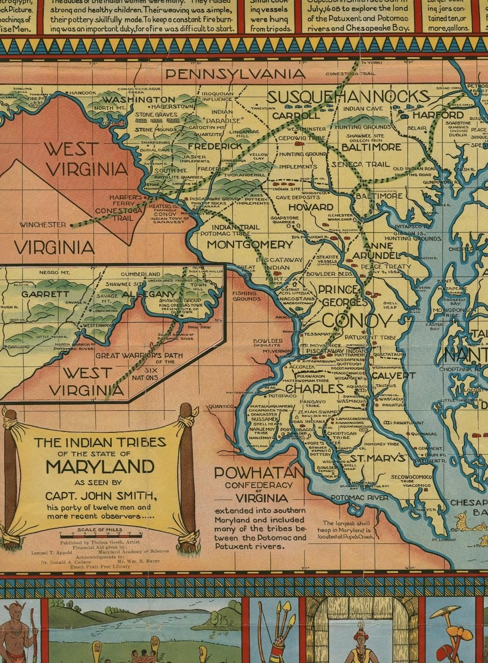

A BRIEF HISTORY OF RACISM IN MARYLAND.
The First Wave of Racism in Maryland: Extermination of the Indigenous People by Europeans

When speaking of racism in the State of Maryland, it is necessary to begin with the arrival of Europeans in the North America, and specifically to the land mass that would eventually be colonized and named “Maryland.” Prior to the arrival of whites from Europe, people indigenous to this region lived in harmonious civilizations filled with high culture, social harmony, and order. Native Americans (also called First Nations people) of this region numbered in the millions, and were classified into two distinct language groups, the Algonquian which occupied the bay area and coastal regions, and the Iroquois which occupied the northern and mountainous regions. Each of these language groups consisted

of various tribes including the Piscataway, Potomac, Susquehannock and Pawtuxant, to name a few of the 30 groups living in this region.³
21.
Many sources attribute the decrease of the indigenous population to diseases brought by Europeans. The reality is that each of these indigenous groups were all but exterminated including the intentional spreading of diseases and also in the form of the so-called French and Indian Wars (1688-1763).⁴ This series of battles is often described as being between the French colonies in North America and the 13 British colonies, and that the war was primarily between Europeans. In the context of racism/White Supremacy, it is clear that the wars were more about the eradication of the Indigenous population in order to seize control of their land and resources. It was a united front amongst the Europeans as long as there was a common enemy, the so-called American Indian. Throughout these various conflicts between the European colonial powers, the Indigenous population was brought to its knees as the French and British fought for dominance of their native soil, often enlisting them as soldiers and allies.
As the Indigenous People were being systematically exterminated, the European population grew in number, control, and power, strengthening their expanding empire and the reach of their idea of White Supremacy. Leading this charge in the region we now call Maryland was the Calvert family.⁵

The Second Wave of Racism in Maryland: Enslavement of Africans

Once the Native American population was successfully decimated and neutralized, the invading Europeans sought to increase their efforts of kidnapping, transporting, working and breeding Africans for the sole and expressed purpose of chattel enslavement. Maryland was second only to Virginia when it came to the exporting of enslaved Africans; these states having the largest ports (Baltimore and Richmond, respectively) from which enslaved Africans were shipped to other parts of the U.S. Territory. When discussing this topic of slavery in Maryland, interns for the Maryland State Archives described the relationship between the enslaver and the enslaved as “parental,” and very much family-like. They quote Charles Cole, an enslaved African, as speaking of his oppressors with “the same regard and affection one might speak of their own family.” Reports such as these, help to perpetuate the myth that slavery was somehow “not so bad,” and that there were “happy slaves” who were treated “well” by their conscientious owners.⁶

Owner of both the Goodwood and Riversdale plantations in Prince George’s County, Lord Baltimore George H. Calvert controlled over 10,000 acres of land while enslaving

³ https://msa.maryland.gov/msa/mdmanual/01glance/native/html/01native.html
⁴ https://www.pri.org/stories/2019-01-31/european-colonization-americas-killed-10-percent-world-population-and-caused
⁵ https://digital.lib.umd.edu/image?pid=umd:56139
⁶ https://msa.maryland.gov/msa/mdslavery/html/antebellum/essay3.html

hundreds of Africans. His parents, Benedict and Elisabeth Calvert owned the Mt. Airy Plantation located in Rosaryville, Maryland contributing to the family business and legacy of cruelty. Other P.G. County based plantations and owners include: Three Sisters (owned by Sarah
Ogle Hilleary); Lake Arbor (owned by Thomas Spriggs Jr.), and Fairview (owned by former Governor Oden Bowie, namesake of Bowie State University).⁷
An enslaved African by the name of Adam Plummer⁸ grew up with and his enslavement was continued by his childhood playmate Charles Benedict Calvert at Riversdale plantation, while his wife Emily Saunders, along with generations of her ancestors, grew up on the aforementioned Three Sisters plantation owned by Hilleary. The Lord Baltimore lineage is thoroughly stained by the legacy of slavery and continues to benefit just the same.⁹

The “Strange Fruit” of Maryland History: Lynchings
Abolishing slavery produced an entirely different set of circumstances for freed Africans and former enslavers of Africans. Many municipalities throughout the state of Maryland were faced with the question of what to do with the large and continually growing populations of “freed” Black people. The State decided it best to deport the soon to be freed Africans and formed the Maryland Colonization Society to assist with this process. If an emancipated African refused to go to Africa, they were forced to leave the state.¹⁰ These mandates were enforced using brutal methods including the systematic lynching and torturing of people of African descent.
According to data compiled by the Equal Justice Initiative (see table below), Maryland ranks 18th in number of lynchings in the United States, recording 28 lynchings between 1877 and 1950 (Mississippi ranked 1st with a recorded 654 for the same period of time). These lynchings were almost always public affairs with several occurring on a courthouse lawn, or to a victim who was, in one way or another, retrieved from the custody of local law enforcement. Fast forward to the 21st century, and these lynchings take the form of the infamous “rough ride” that was suspected to cause Freddie Gray’s death in Baltimore while in police custody, or even the death of Sandra Bland who was accosted along the side of a road, and later found dead in her jail cell.

⁷ https://altarum.org/RacialEquity2018
⁸ http://anacostia.si.edu/exhibits/Plummer/Docs/Teacher_Resources/plummerbio.pdf
⁹ https://www.npr.org/templates/story/story.php?storyId=15383164
¹⁰ http://anacostia.si.edu/exhibits/Plummer/Docs/Teacher_Resources/High_School/hsslaveryreading.pdf

Table 16. Ranking of State Lynchings, Source: The Equal Justice Initiative (2015)

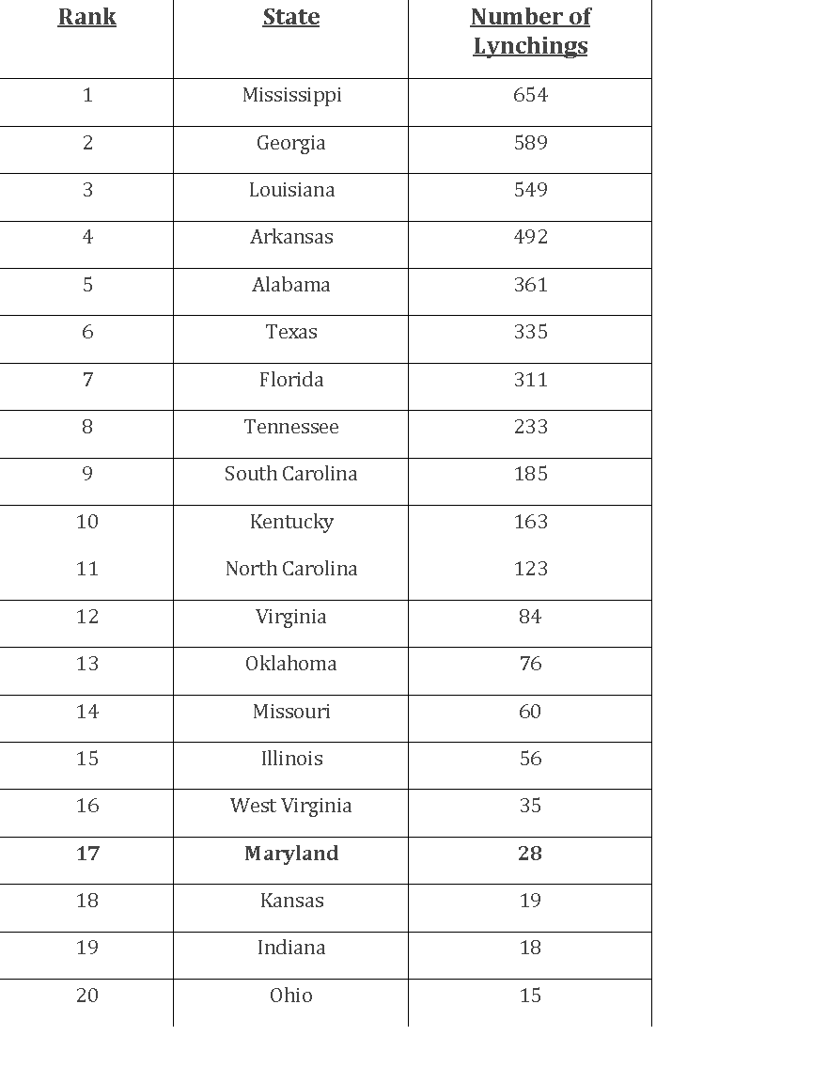
The 1891 lynching of Asbury Green in Queen Anne’s county serves as a vivid example of an American African male being taken from police custody to be lynched. According to the Archives of Maryland, Asbury Green was accused of sexually assaulting the wife of Howard Tolsen, a farmer on Kent Island. Green was convicted and sentenced to 21 years
of hard labor in a State Penitentiary, despite having three witnesses placing him somewhere other than the scene of the crime. Because of this “doubt,” the judge refused to sentence him to death, which sparked the fury of Whites in the region. Prompted by rumors of a pending lynching of Asbury Green, the county sheriff, Thomas B. Turner, increased the number of officers assigned to guard Green. Needless to say, these guards somehow lost control of the prisoner to some 150 to 200 participants making up the lynch mob. Asbury was dragged from his cell by a rope that was tied around his neck, to an orchard where he was eventually hanged. No one was ever convicted of committing this heinous act of violence.

Another well-known lynching in the State of Maryland that gathered political and national attention from as far away as Chicago was the hanging of Matthew Williams of Salisbury. Governor Albert Ritchie received letters from several and various individuals and organizations seeking justice for the wrongful death of Mr. Williams, while also receiving praise for his “fearless and direct official action,” for calling for the arrest of the lynch mob leaders.

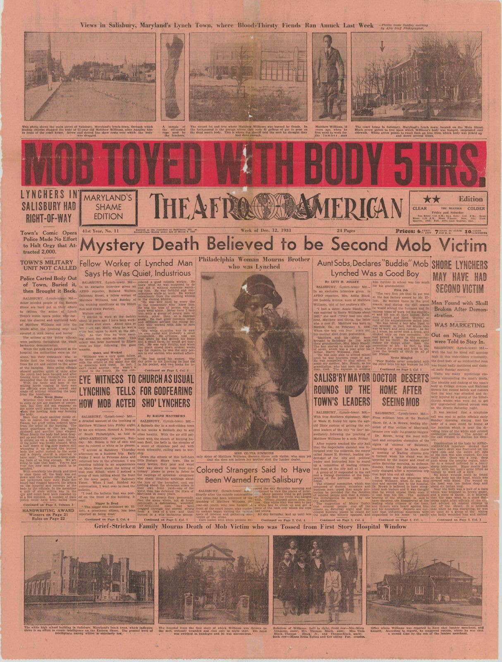

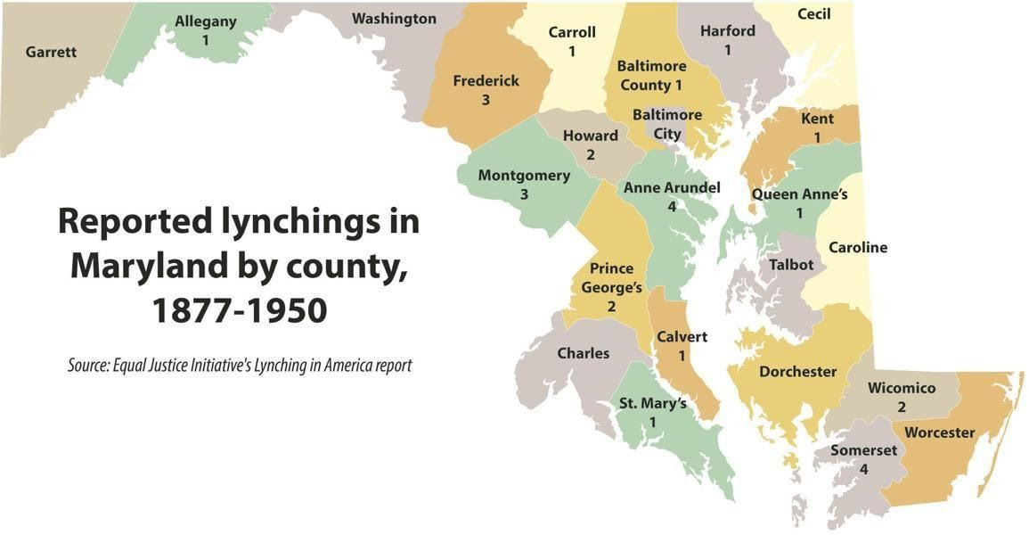

Modern Day Hate Groups in Maryland
As indicated above, the modern form of lynching is police brutality and police misconduct. In a later section of this report, we will detail the race-based disparities found in law enforcement activities. The highlighted disparities include hiring of law enforcement officers, arrest and incarceration rates, as well as the percentages of officer involved shootings and killing of civilians. From the time of initial invasion and war against the Native Americans and the plantations holding Africans in slavery, to the lynchings and post-emancipation horrors visited upon the American African population residing in Maryland, there has always been an organized structure through which racism/white supremacy operates and is refined. According to the Southern Poverty Law Center of Montgomery, Alabama, several hate groups still operate in Maryland including the East Coast Knights of the True Invisible Empire Ku Klux Klan in Cecil County, the Confederate Knights of the Ku Klux Klan in Baltimore County, The Right Stuff in Baltimore City and statewide groups such as Identity Evropa and Virginia Christian Alliance an anti-Muslim group.

With such widespread and organized hatred, there is no wonder why systemic racism is so effective and efficient at carrying out its goals. Mr. Neely Fuller, Jr. often speaks of nine basic areas of people activity, all of which are dominated by racism/White Supremacy. In these nine areas (Economics, Education, Entertainment, Labor, Law, Politics, Religion, Sex, and War), a power dynamic is established, maintained, expanded, and refined that keeps whites superior to Blacks in most, if not all, activities and systems. In other words, this system is constructed to maintain White Supremacy by any necessary means. One of the most impactful areas that this occurs in is that of health and wellbeing.

Institutional Practices Involving Racism

In the State of Maryland, Johns Hopkins University, The Johns Hopkins University Medical Center, and various affiliates such as the Kennedy Krieger Institute (KKI), have a history of segregating patients as do other hospitals in state. For example, in the mid ‘90s, the KKI conducted a lead abatement experiment on 100 homes in Baltimore. During these experiments, children were intentionally exposed to lead dust without their knowledge, resulting in elevated serum lead levels and the subsequent brain damage and related issues. Prior to the discovery of their unethical lead research, there was an asthma study that caused them to lose their license to conduct human experiments.¹¹

In 1960, famed “Goon Squad” member and Morgan State University economist Homer Favor feared having to take his own 3-year-old son to Johns Hopkins’ emergency room. During this time, Blacks and whites were treated in separate parts of the hospital, making it easy to have disparities of treatment and care. In addition to this obvious inequity were the pervasive tales of Hopkins’ use of Black people as “guinea pigs.” Dr. Favor had to overcome these fears in order to attempt to save his son’s life. Fortunately, this story has a happy ending with Favor’s son having a successful, life-saving appendectomy.¹²

In addition to the aforementioned occurrences, Hopkins has also been charged with spreading an experimental “sludge” on the yards of East Baltimore residents in the year 2000. This was part of an ongoing experiment they were conducting to reduce the amount of lead in the soil. The fertilizer or “compost,” as it was sometimes called, contained both human and industrial waste and is thought to be responsible for several illnesses to residents who were intentionally exposed to the toxic biohazard. The NAACP called for a criminal investigation on both the state and federal levels.

¹¹ (Josefson D. (2001). Johns Hopkins faces further criticism over experiments. BMJ (Clinical research ed.), 323(7312), 531
¹² https://www.baltimoresun.com/news/bs-xpm-2008-04-23-0804230255-story.html

“Many of the contours of opportunity for individuals and groups in the United States are defined—or ‘structured’—by race and racism. The term structural racism refers to a system in which public policies, institutional practices, cultural representations, and other norms work in various, often reinforcing ways to perpetuate racial group inequity. It identifies dimensions of our history and culture that have allowed privileges associated with ‘whiteness’ and disadvantages associated with ‘color’ to endure and adapt over time.”
--- Aspen Institute, Structural Racism and Community Building, 2004

HEALTH AND HEALTH CARE DISPARITIES IN MARYLAND.
Health is a dynamic state of complete physical, mental, spiritual and social well-being and not just the absence of disease or infirmity. According to the World Health Organization, better health is central to human happiness and wellbeing, as well as an important contributor to the economic progress since healthy populations live longer, are more productive and save more. Overall, the United States spends more on healthcare than any other nation, but experiences fewer positive results in health maintenance as compared to many other developed nations in the world. One of the major contributors to the United States overall poor health outcomes is the fact that there is a major disparity in both the delivery of healthcare services as well as access to healthcare among the various racial and ethnic groups in the country.

What is “Health Disparity?”

According to the 2002 Institute of Medicine’s Unequal Treatment Report,¹³ Health and healthcare disparities refer to differences in health and health care between groups that are closely linked with social, economic, and/or environmental disadvantage. Disparities occur in many dimensions, including race and ethnicity, socioeconomic status, age, location, gender, disability status and sexual orientation. Health disparity leads to a higher burden of illness, injury, disability, or mortality experienced by one group relative to another. It can also refer to differences between groups in health insurance coverage, access to and use of care, and quality of care. Such disparity leads to a disproportionate burden of diseases or death among one racial, ethnic or socioeconomic group as compared to the other. When one looks across the entire spectrum of the major health indicators, African Americans and other underrepresented groups experience a high level of health disparity as compared to their white counterparts leading to a reduced life expectancy among this racial group. On the average, white Americans live 4-5 years longer than their African American counterparts.

¹³ Bussing, Regina and Gary, Faye: Eliminating Mental Health Disparities by 2020: Everyone's Actions Matter, July 2012, Journal of the American Academy of Child and Adolescent Psychiatry 51(7):663-6

Figure 1: Life Expectancy at Birth, by Race and Sex: United States, 1970-2017

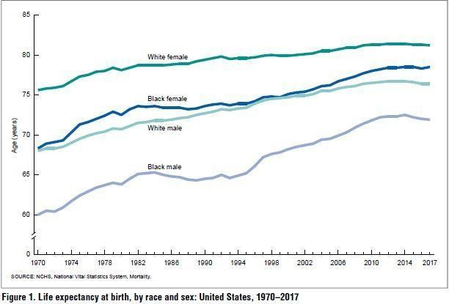

Several studies have shown that African Americans have higher rates of mortality than other racial or ethnic groups for 8 of the 10 major causes of death. Analysis estimates that these disparities amount to approximately $93 billion in excess medical care costs and $42 billion in lost productivity per year as well as economic losses due to premature deaths¹⁴. A major contributor to health disparity is the lack of access to health care. According to a report by the Henry Kaiser Foundation, African Americans ranked higher in comparison to their White counterparts in the rate of uninsured nonelderly population for the years 2010-2018¹⁵.

¹⁴ https://altarum.org/RacialEquity2018
¹⁵ https://altarum.org/RacialEquity2018

Figure 2: Uninsured Rates for the Nonelderly Population by Race and Ethnicity, 210-2018

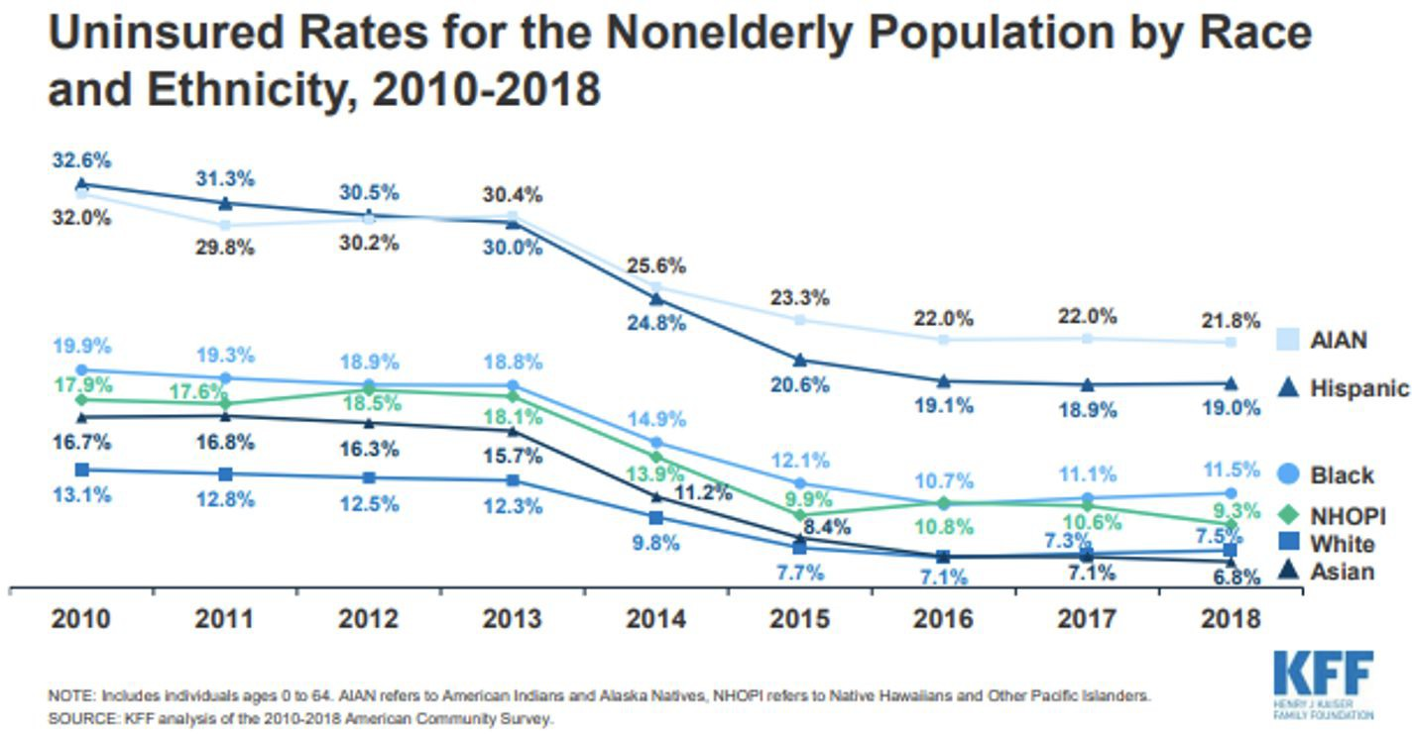

This high rate of uninsured populations account for those who did not receive care or delayed care during the years that the study was conducted.

Also, at the national level, the age adjusted death rates for heart disease, the number one cause of death, is much higher for African Americans than for any other racial group. The cancer incidence rate among African Americans is 10% higher than among European Americans (American Public Health Association, Eliminating Health Disparity: Toolkit (2004).

Figure 3: Share of Nonelderly Adults Who Did Not Receive Care or Delayed Care in the Past Year by Race/Ethnicity, 2018

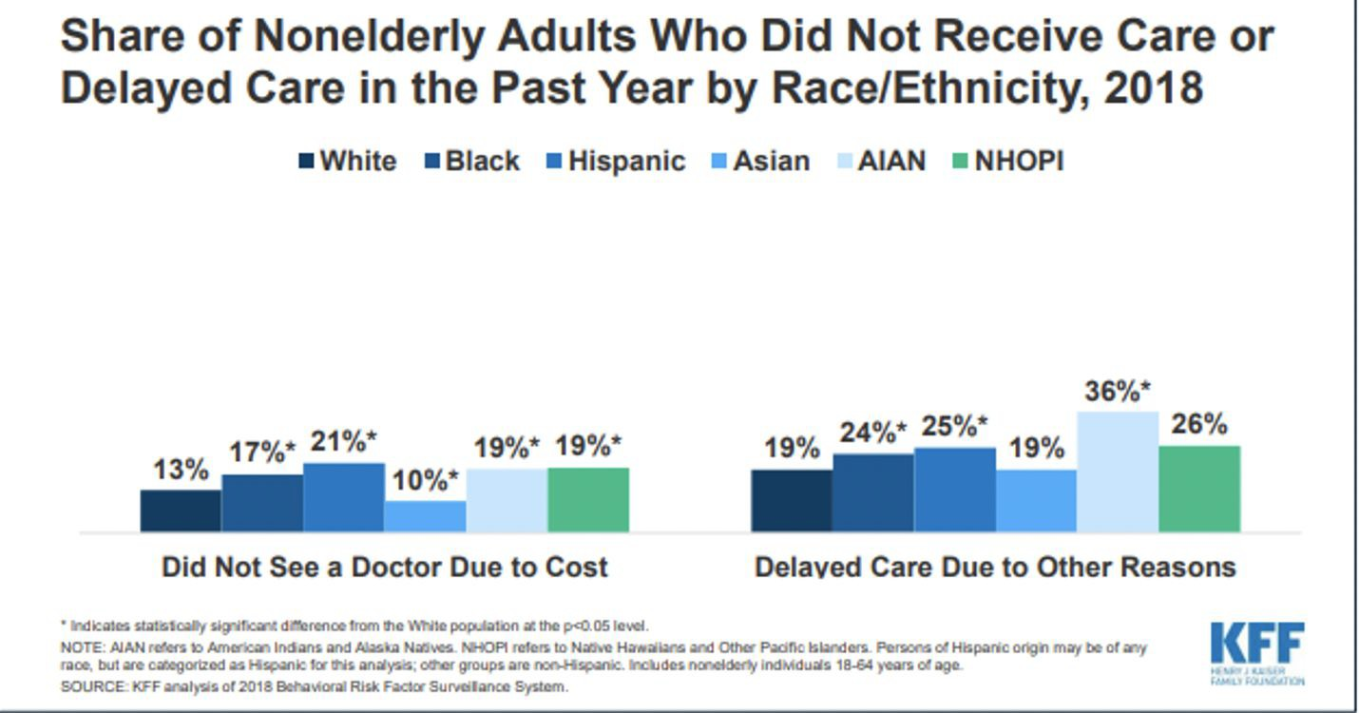
Figure 4: Age-adjusted Death Rates for Heart Disease, by Race and Latinx Origin; 1999-2017¹⁶

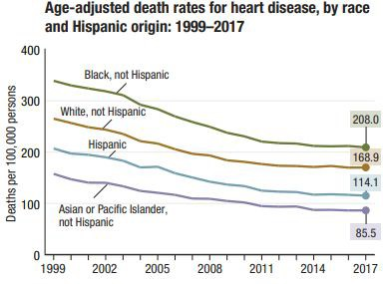

In most cases, disparity exists due to inequities in the distribution or provision of the necessary healthcare services in the society.

¹⁶ Ellison, C. G., Hummer, R. A., Cormier, S., & Rogers, R. G. (2000). Religious involvement and mortality risk among African American adults. Research on Aging, 22(6), 630–667.

Health and Health Care Disparity in Maryland

The State of Maryland is not exempt from the same health care disparities that exist at the national level. The state continues to face the challenges of having populations facing disproportionate burdens of disease and deaths that prevent them from living healthy and fulfilled lives. Health disparities and inequities in health and health care can be seen across every indicator at the state and local (county) level in Maryland. According to the table below, in Maryland, African Americans constitute only about 30% of the total population yet accounted for nearly 50% of confirmed cases and 50% of confirmed COVID related deaths for which race has been assigned. This statistic is consistent with several other states in the study.

Table 17.
SARS-CoV-2 Percentage of Cases and Deaths in Communities of Color in Select States*
Ethnicity (State) | %age of Cases | %age of Deaths | %age of State Population
African Americans (MD) | 47% | 50% | 30%
African Americans (WI) | 25% | 41% | 7%
African Americans (IL⁾ | 26% | 42% | 15%
African Americans (LA) | N/A | 60% | 33%
Native American (NM) | 37% | N/A | 10%
African Americans (CA) | 7% | 10% | 6%
Latinos (CA) | 35% | 28% | 39%
Asians (CA) | 13% | 16% | 15%
*Data as of Wednesday, April 15, 2020

Data obtained from the Maryland Office of Minority Health, reveals startling disparities on a wide range of major health indicators. The average life expectancy for African Americans during the past ten years (2009-2018) is at least 3-4 years lower than their white counterpart for each of the ten years.¹⁷

Figure 5: Life Expectancy at Birth by Race, Maryland 2009-2018

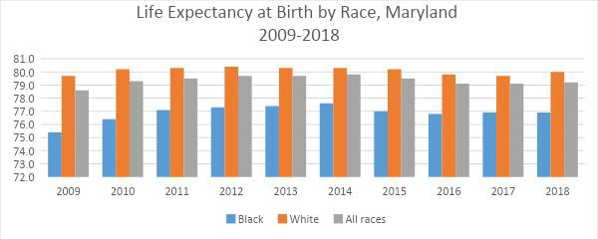

The age adjusted death rate for all causes shows that for each of the ten years studied, the death rate was higher among African Americans compared to their white counterparts with 2009 being the highest (906 vs 749) and 2014 being the lowest (794 vs 705) for every
100,000 deaths (see Figures 6-15 below).¹⁸

Figure 6: Age Adjusted Death Rate for all Causes by Race, Maryland, 2009-2018

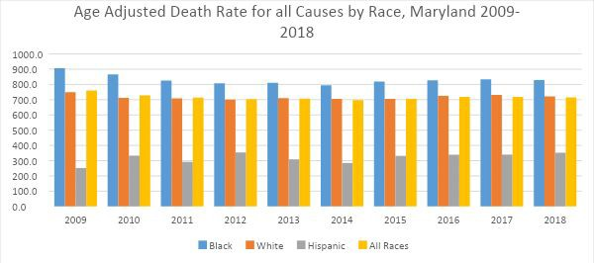

¹⁷ https://health.maryland.gov/vsa/Documents/Reports%20and%20Data/Annual%20Reports/2018annual_rev3.pdf
¹⁸ https://health.maryland.gov/vsa/Documents/Reports%20and%20Data/Annual%20Reports/2018annual_rev3.pdf

A review of the two leading mortality causes (Heart Disease and Malignant Neoplasm) equally shows that African Americans have higher death rates from these causes than their white counterparts.

Figure 8: Age Adjusted Death Rate for Malignant Neoplasm by Race, Maryland 2009-2018
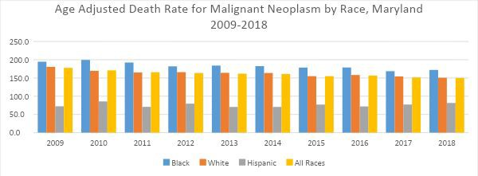

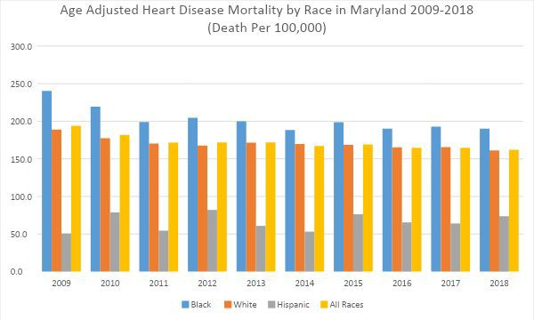
.

Additionally, infant mortality -- which refers to the death of infants before their first birthday -- reveals that African Americans were three times more likely to have their infants die during their first year than their white counterparts. Additionally, the percentage of births to women receiving late or no prenatal care by race shows a major disparity, with African American women being more than twice as likely for this to occur among them than among white women. Ironically, these data show that while the rate of late or no prenatal care among African Americans and Latinas/Latinx mirrors each other for some of the years studied, there remains a major gap between the rate of infant mortality for the two groups (with African Americans having rates that are twice that of the Latina/Latinx population.) This then leaves one to wonder why there is such a huge disparity.
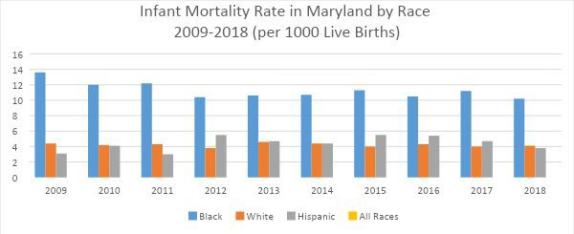
Figure 10: Late or No Pre-Natal Care by Race in Maryland, 2011-2018 (Per 1000 Live Births)
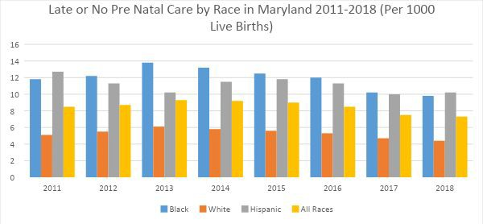

ACCESS TO HEALTH CARE SERVICEs

Similar to the United States, Maryland continues to lag behind in the rate of its citizens having universal access to health care. Access to health services means the timely use of personal health services to achieve the best health outcome. Studies have shown that access to care is a major determinant on whether one receives health care and as to when due. A review of the U.S Census American Community survey data (2018 5-year estimate) reveals varying rates of uninsured African American populations in the various counties in Maryland. The data indicate that the rate of uninsured populations is much higher among African Americans compared to whites in 19 of the 24 jurisdictions in the state, resulting in reduced ability to see a doctor of choice when needed.

Figure 11: Percentage of Maryland Adults Unable to See A Doctor, 2006-2010
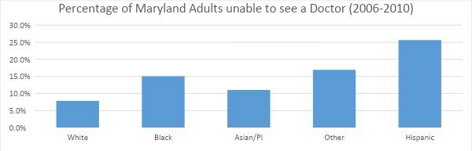

MENTAL HEALTH SERVICES

According to the U.S. Surgeon General’s Report on Mental Health (1999), protected racial and ethnic groups have less access to mental health services than whites, are less likely to receive needed care, and are more likely to receive poor-quality care when treated. Also, First World People are more likely than whites to delay or fail to seek mental health treatment. A more recent report by the National Healthcare Quality and Disparities¹⁹ show that First World People still have less access to mental health services than whites, and when they receive care, it is more likely to be of poorer quality. The tables below show percentage of Maryland adults reporting 30 days of poor mental health in the previous month as well as the percentage that reported seeing a mental health provider during the same time period.

¹⁹ Bussing, Regina and Gary, Faye: Eliminating Mental Health Disparities by 2020: Everyone's Actions Matter, July 2012, Journal of the American Academy of Child and Adolescent Psychiatry 51(7):663-6

Figure 12: Percentage of Maryland Adults Reporting 30 days of Poor Mental Health in Previous Month by Race, 2010
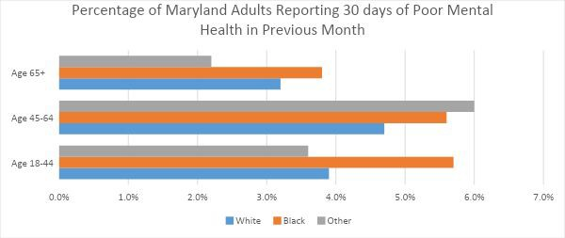

Figure 13: Percentage of Maryland Adults Reporting Seeing a Provider for Mental Health Issues by Race 2010
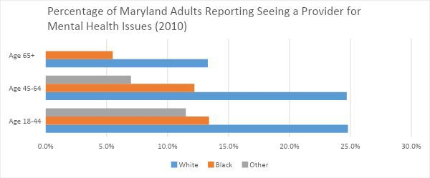
This disparity in mental health issue can be attributed to a number of factors. First, this disparity could be due to 1) discriminatory behavior on the part of providers, i.e., treating otherwise similar patients differently according to race/ethnicity, and/or disparity due to access, insurance, and other factors associated with the operation of the health care system. Other factors could also include a lack of availability of mental health services, transportation to the facility, belief that mental health care does not work, or the stigma associated with mental health. Addressing these challenges of mental health care would require a more holistic approach that will be culturally sensitive to groups of color.

Figure 14: Racial/Ethnic Distribution of Physicians and Population in Maryland by Race, 2007
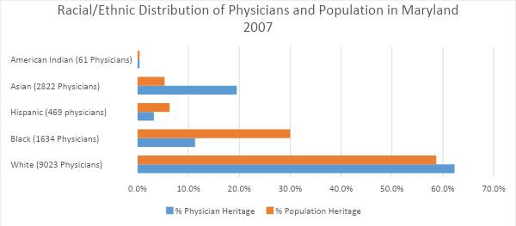
DISCUSSION AND RECOMMENDATIONS

Healthy People 2020²⁰, the nation’s health agenda for promoting health and preventing diseases, identifies social determinants of health as its leading health indicator for improving the health of American citizens during the next ten years. Social determinants of health are conditions in the environments in which people are born, live, learn, work, play, worship, and age that affect a wide range of health, functioning and quality of life outcomes and risk conditions. Resources that enhance quality of life can have significant influence on health outcomes. Examples of these resources include safe and affordable housing, access to education, public safety, availability of healthy foods, local emergency/health services, and environments free of life-threatening toxins. The Centers for Disease Control and Prevention (CDC), the nation’s premier public health agency, states that addressing issues related to social determinants accounts for over 60% of our health conditions both good and bad. African Americans, because of their 400+-year history of experiencing racism/white supremacy, have found themselves subjected to these living conditions, and those conditions have contributed to much of their negative health conditions. These health conditions can be improved through the following measures:

- Collaborative engagement of both the public and private sectors to enact positive policy changes that address the historical trauma of racism/white supremacy.
- Invest in low-income communities, improve educational institutions and create job opportunities.

²⁰ https://www.healthypeople.gov/2020

- Expand community health services, provide training for healthcare workers and improve patient/provider relationships.
- Provide good housing and decent grocery stores to meet daily needs.
- Develop and implement stiff penalties for doctors found to engage in malpractice.

Racism, Environmental Justice, and Public Health in the State of Maryland

Environmental justice intersects with racism and public health. Our investigation focused on the health risks associated with air pollution and food deserts. Air pollution comes from two sources: point smoke (ground) and mobile (transportation). In this report pollution and food source data is reported by the following organizations: point source data is reported by the Lung Association for Maryland counties; mobile source data is derived by relying on the risk model developed by the Tim Buckley Baltimore Regional Environmental Justice Project (2013) and food deserts information is from Baltimore City, Mapping Baltimore Cities Food Environment. Together these data sources show the impact that racism has had through the medium of smokestacks, traffic, and food accessibility.

Intersectionality of EJ and Public Health

The term “Environmental justice” (EJ) is used to describe the movement concerned with inequities in the distribution of adverse environmental and health consequences of industrial activities and environmental policies (U.S.EPA 2004). The movement grew from early observations that a seemingly unequal burden of pollution fell on disenfranchised and disadvantaged communities, often characterized by lower incomes and high proportions of minorities (Brown 1995).

In theory EJ is defined as the fair treatment and meaningful involvement of all people regardless of race, color, national origin, or income with respect to the development, implementation, and enforcement of environmental laws, regulations, and policies. Fair treatment means that no group of people, including a racial, ethnic, or a socioeconomic group, should bear a disproportionate share of the negative environmental consequences resulting from industrial, municipal, and commercial operations or the execution of federal, state, local, and tribal programs and policies. Meaningful involvement has the objective of enhancing the engagement of community members more directly in the process of defining the problem, working to understand its causes and impacts, quantifying those impacts, exploring a range of potential solutions and getting meaningful results.

In practice, two components of EJ are theoretically codified in law by Title VI of the 1964 Civil Rights Act, which explicitly focuses on the distribution of benefits. Title VI reads: ‘No

person in the United States shall, on the ground of race, color, or national origin, be excluded from participation in, be denied the benefits of, or be subjected to discrimination under any program or activity receiving federal financial assistance’.

Air Pollution, Public Health and Environmental Justice

There is a growing recognition among public health, planning, and transportation professionals that land-use and transportation planning decisions can have a substantial impact on the public’s health. Point sources of pollution are elevated at ground-level. For example, emissions from a combustion furnace stack. Air pollution also emanates from mobile sources. For example, Wu and Batterman (2006) found that students attending schools near high traffic roads (less than 500 feet, more than 5000 trucks passing the area by day) were more likely to be Black or Latinx and to reside in poor neighborhoods. This is an example of how just one policy decision, i.e., traffic patterns, is related to policy decisions and impact health.

The epidemiology of air pollution and human health is both complicated and well established, (Michael Buzzelli, 2018). As shown in Table 18 EJ and public health research has come to inform a range of studies.
Table 18: Public Health Matrix²¹
Category | Distance to Traffic | Traffic Density | Health Effects Assessed | Exposure Metric | Reported Effects with Positive Association | 95% CI
Respirator y | 550 ft | 5,500-9,0  00 | Prevalence of Asthma | ADT  Distance to Residence | Asthma Related Doctor Visits | 1.10
Asthma | 200 m | >%Heavy Trucks | Asthma Hospital Admission  s | ADT  Distance to Residence | Asthma Hospital Admissions | 1.13-  3.29
Mortality | 100 m Freeway  50 m Urban Road | n/a | Cohort Mortality | Residential Distance to Freeway and Urban Road | Cardiopulmonar y  Mortality | 1.09-  3.52

Adverse | 500 m | 93,000  Vehicles per day | Preterm Delivery | Residential Distance to Freeway | Preterm Delivery | 1.03-  1.65
Nancy Kipp, NIH,2007

Health Impacts from Soot and Smog Air Pollution
Emissions from cars, trucks, industrial smokestacks, trains, boats, and commercial heating systems contribute to the death of 113 people per 100,000 population per year in Maryland- more than any other state (Massachusetts Institute of Technology, August 2020). In Baltimore, its 130 people per 100,000. In Table 19: the American Lung Association in its “State of the Air 2018”, reports that while Baltimore ranked 17th among 227 metropolitan areas only one of 10 Maryland counties received an “A: for both smog and soot levels. Figures 1- 4 contrasts low-income and middle-income exposure to emission.
The summary of data in Table 19 shows that the counties with the lowest scores have high population concentrations of Black and Latinx populations.

Table 19: County Grades in Maryland

City or Town 2010 Total Population
2017 Total Population
Smog & Soot
Black Latinx

Anne Arundel | 537,631 571,595 F/A 66,122 46,562
Baltimore City | 620,862 | 609,841 | F/B | 418,282 | 33,061
Baltimore | 805,229 571,592 F/A 151,409 46,562
County
Calvert | 88,739 | 91,365 | C/DNC | 9,745 | 3,818
Carroll | 167,142 167,620 C/DNC 3,420 46,820
Cecil | 101,102 | 102,573 | F/A | 3,340 | 4,698
Charles | 146,565 159,451 F/DNC 31,323 9,754
Dorchester | 32,623 | 32,145 | C/A | 8,690 | 1,903
Frederick | 233,391 250,959 C/DNC 12,359 25,987
Garrett | 30,139 | 29,261 | A/A | 127 | 356
Harford | 244,826 251,890 F/A 20,132 12,037
Howard | 287,123 | 319,374 | DNC/A | 35,779 | 23,099
Kent | 20,195 102,573 F/F 3,327 840
Montgomery | 971,964 | 1,048,244 | C/A | 132,675 | 209,032
Prince Georges | 863,349 908,108 F/A 502,335 173,294
Washington | 147,430 | 150,288 | C/B | ,21410 | 8,144

Health Risk
Source: American Lung Association and Maryland Statistical Handbook, 2017

Across Maryland, the impact of transportation on public health is a growing concern in many metropolitan areas. We focused on Baltimore, Maryland a major metropolitan area in the United States to illustrate how existing information can be used in identifying communities at risk. Baltimore is typical of many old large east coast cities with a housing stock that is dominated by row homes built near busy urban arterial roadways. The maps in figures
15-18 identify building-level “hot spots” within communities where it would be reasonable to hypothesize that individuals are at risk due to the combined influence of low SES and proximity to high levels of traffic. As would be expected, it can be observed that the highest index values are associated with homes in close proximity to highways and busy urban arterials, however, this influence and risk can be offset by blocks with high income.

An environmental justice risk modeling was applied to four Baltimore communities (Cherry Hill, Federal Hill, Kirk Avenue, and Highway to Nowhere) to exemplify it as a tool as a part of the Baltimore Region Environmental Justice in Transportation Project (BREJTP).

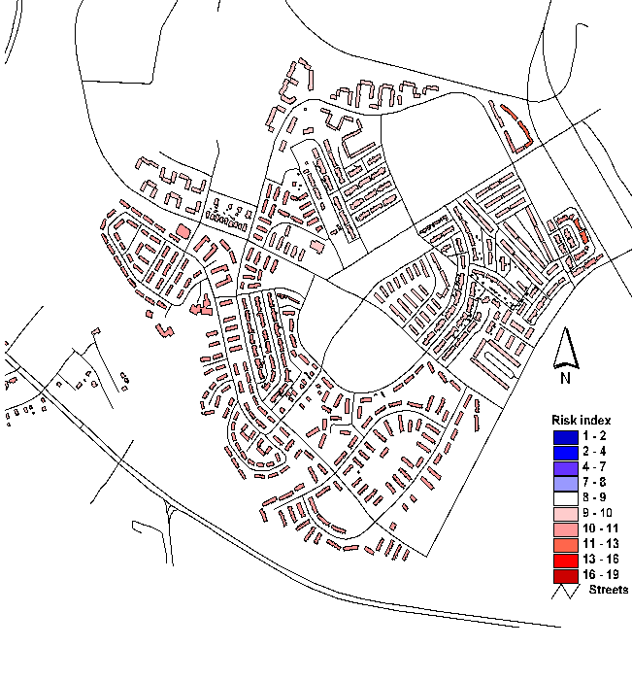

Source: Baltimore Regional Environmental Justice Project 2013

Figure 16: Federal Hill

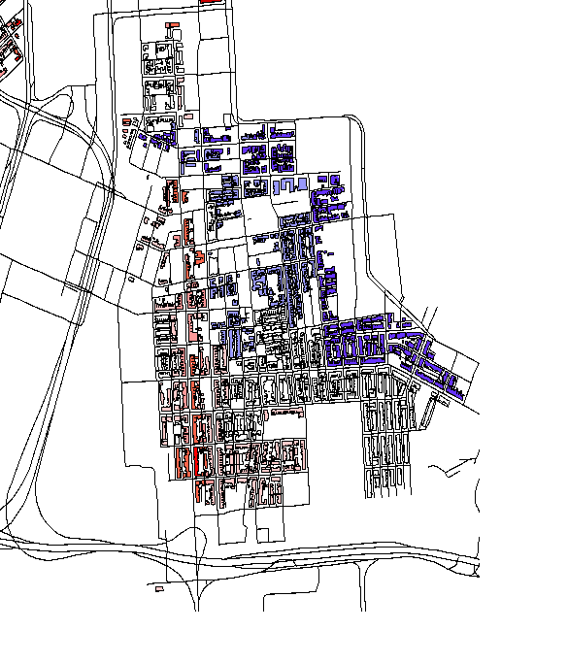
Source: Baltimore Regional Environmental Justice Project 2013

Figure 17: Kirk Ave

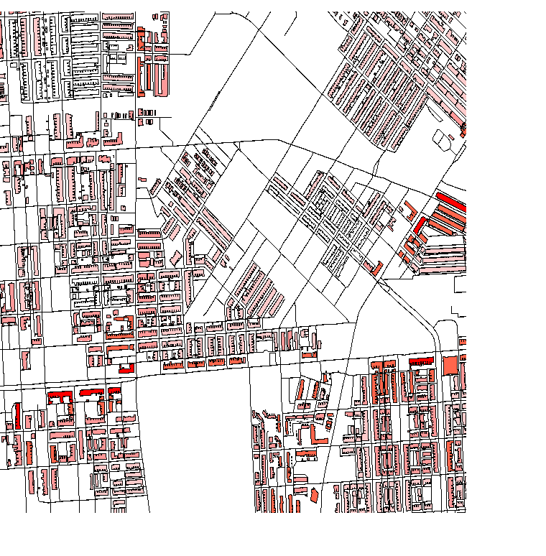

Source: Baltimore Regional Environmental Justice Project 2013

Figure 18: "Highway to Nowhere”

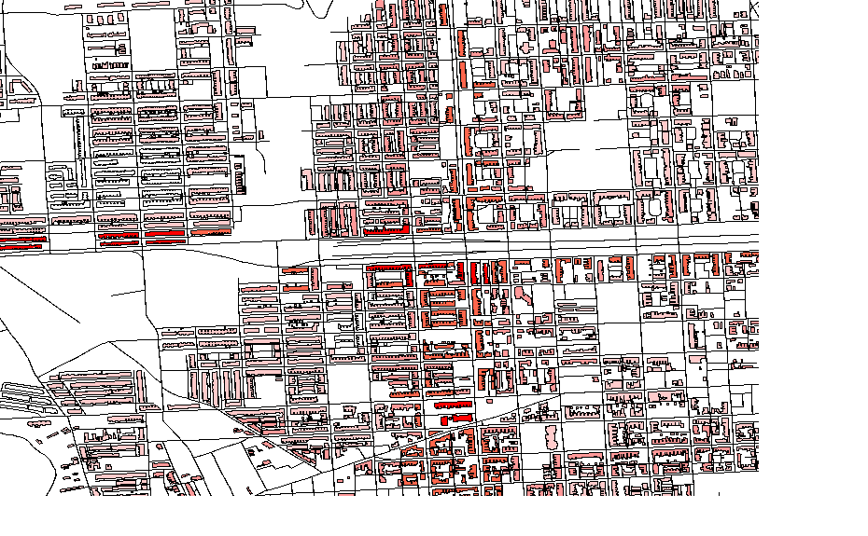
Source: Baltimore Regional Environmental Justice Project 2013

Discussion

That socioeconomic status (SES) and roadway proximity are proxies that explain how transportation activity impacts the public health of low-income households is well defined in the research literature. In Baltimore, strong evidence exists that proximity to heavily trafficked roadways and SES conspire to place communities at risk for health threats that range from cardiovascular disease to cancer, although research is needed to fully elucidate the nature of the risk and to develop strategies for mitigation.

Food Deserts and Environmental Justice

Maps in Figures 19-20 show environmental racism as it relates to food access in the State of Maryland. In the simplest terms, environmental justice as defined in the EJ executive order mandates that federal funds not be spent in a way that has a disparate impact on low income and minority communities. Simply stated, EJ is the notion that all members of society, regardless of race and socioeconomic class, should share environment burdens and benefits equitably (Reynolds, 2013, p. 15). Figures 21-22 show the number of people with the least and most access.

Figure 19: 2010 Population Totals

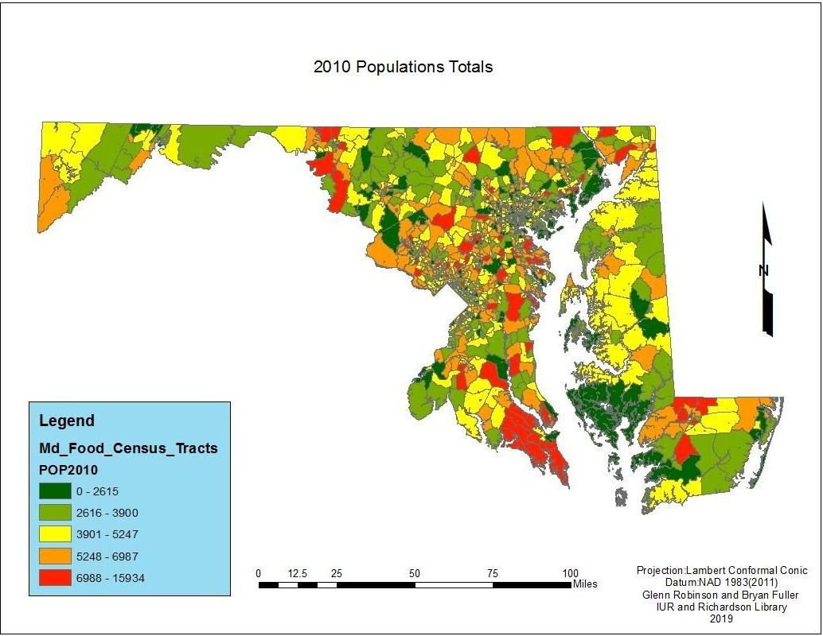

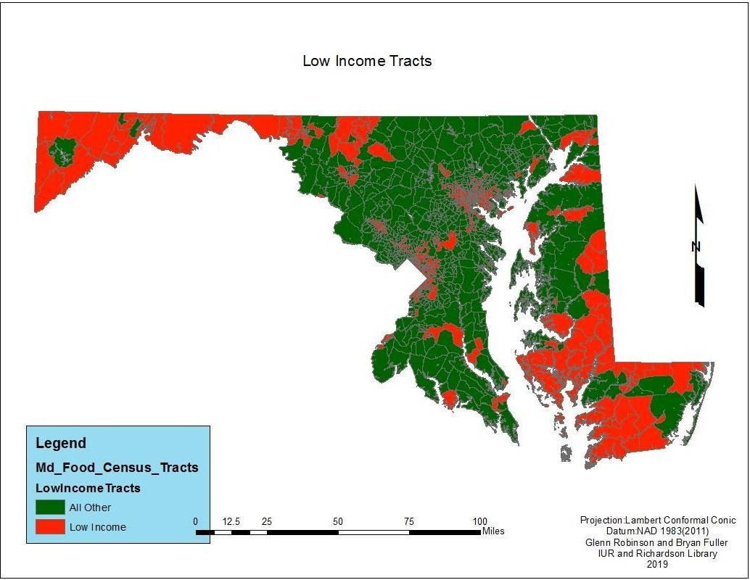
Figure 20: Low Income Census Tracts

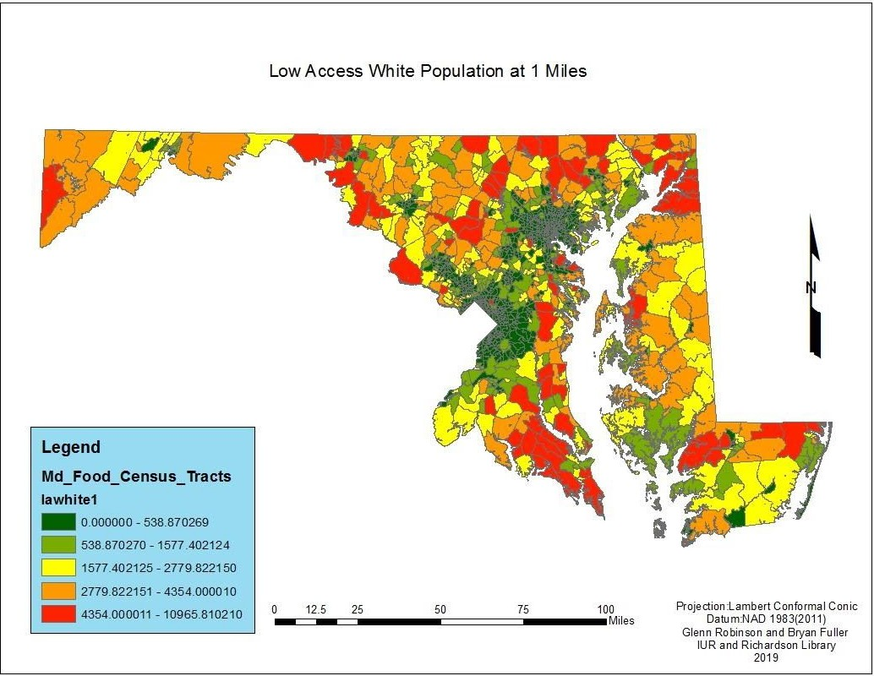
Figure 21: Low Access White Population at 1 Mile

Figure 22: Low Access Black Population at 1 Mile
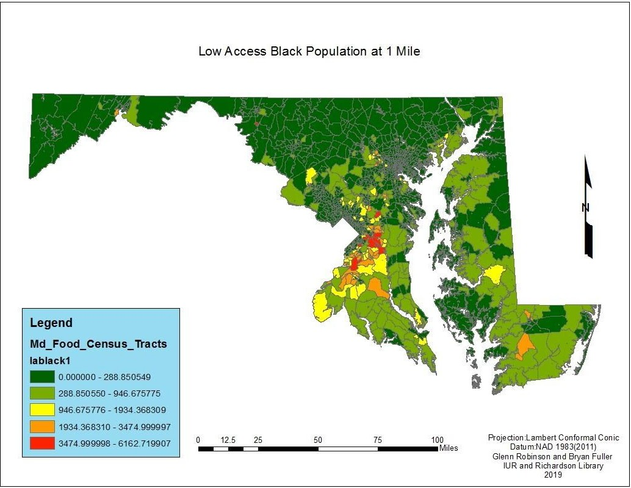

Disparities in Healthy Food Access shows the percent of low SES and racial minority/people of color who live in neighborhoods within councilmanic districts where there are constraints to accessing healthy, and affordable food options. Like air pollution (point and mobile) food deserts are associated with disproportionately high rates of diet-related disease.

Figure 23: Proximity to supermarket: areas more than 1⁄4 mile from nearest supermarket*

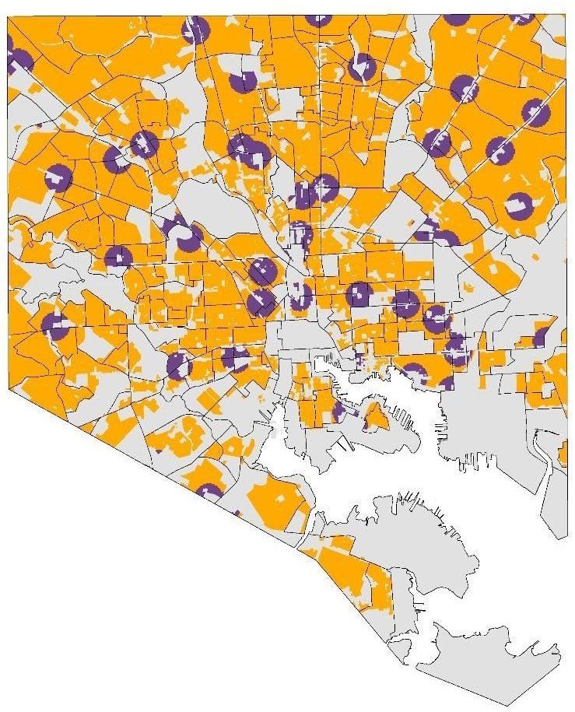

Figure 24: Percentage of Each Population Group Living In Food Deserts in Baltimore City*

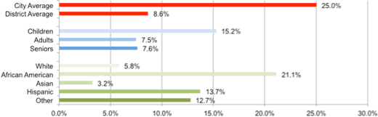

*Source: Mapping Baltimore City’s Food Environment, 2015 Report

Environmental Justice Policy Considerations

Predictably in at-risk neighborhoods a mix of problematic actions conspire to work against revitalization--out-migration, housing abandonment, predatory real estate practices, expanding criminal activity, random violence, and personal fear. The fact is that, because of the long process of demographic, social, racial, class and physical change, poor neighborhoods have been left out revitalization in many historic core cities. The following issues require remedial legislative actions.

- Source of income discrimination needs to be addressed.
- The cumulative impacts of projects need to be considered and eliminated or ameliorated
where possible.
- Use Social Equity Impact Assessment to evaluate proposed public policy initiatives before implementation.

Many organizations are issuing statements against racism, but actual actions taken need to be evaluated for effectiveness and follow-through. For any policy or project, decision makers should consider: 1) Distributional Equity: Does the distribution of civic resources and investment explicitly account for potential racially disparate outcomes? 2) Transgenerational Equity: Does the policy or project result in unfair burdens on future generations? 3) Structural Equity: What historic advantages or disadvantages have affected residents in the given community? 4.) Procedural Equity: How are residents who have been historically excluded from planning processes being authentically included in included in the planning, implementation, and evaluation of the proposed policy or project?

Recommendations
The subtext message in this analysis is that environmental justice is a key equity and anti-racism ingredient in sustaining and improving neighborhood, community, city and regional well-being.

While federal regulations now exist that identify principles of EJ, the legal system recognizes no universally accepted definition of EJ, and its standing as an enforceable right has been tested through the court system with mixed outcomes. It has only been since 1997 that plaintiffs began winning EJ cases, which did not require proof of intent. That said, we rely on the forward leaning Executive Order 12898 and a steady stream of Title VI complaints, a lagging indicator, to justify and underpin the argument for a more balanced urban development approach. This recognizes that identifying the problem is 9/10ths of the task of identifying the correct analysis approach and, ultimately, a best fit solution. This places great weight on the process of problem formulation and is supported by the NRC 2009 report “Science and Decisions” supports this perspective.

Our Recommendations:

- Require state planning agencies to share and provide data and technical assistance to low- income and communities of color. Environmental Justice Analysis requires integration with the community and should not be left wholly in the domain of technicians nor should the public involvement process be denied critical information, even if it is complex (or potentially controversial).

- Pursue anti-racist policy and environmental justice through the medium of transit-oriented development projects, context sensitive designs and the mitigation of negative cumulative impacts that promote community well-being through small scale interventions, workforce development, community greening and mixed-use land use developments.

- Ensure, through all possible means, that EJ communities have opportunities and access equitable to those of the most “important” stakeholders. Indicators such as travel time, accessibility, number of trips, emissions, noise, and congestion are key measures to discern whether government funded projects conform to existing law.

- Ensure, through all possible means, that planning organizations are realigned so that EJ communities are treated equitably in terms of the opportunities and access afforded them for meaningful public participation.

- Adopt a flexible standard for analytic tools, data and capabilities across agencies that engage in environmental justice evaluations and problem solving.

- Center Equity, as every problem or assessment of equity or proportionality in benefits or burdens involves “tradeoffs” to all parties. Effective solutions require compromise which comes from informed awareness of the racialized (historical) root causes and resulting (current) disproportionalities, relevant benefits, burdens, and associated trade-offs.

- Provide EJ research funding at Maryland’s HBCUs, to identify communities at risk and to focus on project design that blends a mix of transportation, housing, health, land use and smart growth elements.

Appendix A: References
Apelberg, B. J.; Buckley, T. J.; White, R. H. Socioeconomic and racial disparities in cancer risk from air toxics in Maryland; Environ. Health Perspect. 2005, 113, 693-699.

Bigert, C.; Gustavsson, P.; Hallqvist, J.; Hogstedt, C.; Lewne, M.; Plato, N.; Reuterwall, C.; Scheele, P. Myocardial infarction among professional drivers; Epidemiology 2003, 14, 333-339.

Brown, P. 1995. Race, Class, and Environmental-Health - A Review and Systematization of the Literature. Environmental Research 69:15-30.

Brunekreef, B.; Janssen, N. A.; de Hartog, J.; Harssema, H.; Knape, M.; van Vliet, P. Air pollution from truck traffic and lung function in children living near motorways; Epidemiology 1997, 8, 298-303.

Caldwell, JC, Woodruff, TJ, Morello-Frosch, R, Axelrad, DA. 1998. Application of health information to hazardous air pollutants modeled in EPA's Cumulative Exposure Project. Toxicology and Industrial Health 14:429-454.

Clinton,WJ. 1994. Executive Order 12898: Federal actions to address environmental justice in minority population and low income populations. Fed Reg 59(32).

Friedman, M. S.; Powell, K. E.; Hutwagner, L.; Graham, L. M.; Teague, W. G. Impact of changes in transportation and commuting behaviors during the 1996 Summer Olympic Games in Atlanta on air quality and childhood asthma; JAMA 2001, 285, 897-905.

Green, RS, Smorodinsky, S, Kim, JJ, McLaughlin, R, Ostro, B. 2004. Proximity of California public schools to busy roads. Environmental Health Perspectives 112:61-66.

Gunier, RB, Hertz, A, Von Behren, J, Reynolds, P. 2003. Traffic density in California: Socioeconomic and ethnic differences among potentially exposed children. Journal of Exposure Analysis and Environmental Epidemiology 13:240-246.

Institute of Medicine, eds. 1999. Toward environmental justice: research, education, and health policy needs. Washington, D.C: National Academies Press.

Knox, E. G. Oil combustion and childhood cancers; J. Epidemiol. Community Health 2005, 59, 755-760.

Lopez, R. 2002. Segregation and Black/White differences in exposure to air toxics in 1990. Environmental Health Perspectives 110:289-295.

Morello-Frosch, R, Pastor, M, Porras, C, Sadd, J. 2002. Environmental justice and regional inequality in southern California: Implications for future research. Environmental Health Perspectives 110:149-154.

Morello-Frosch, RA, Woodruff, TJ, Axelrad, DA, Caldwell, JC. 2000. Air toxics and health risks in California: The public health implications of outdoor concentrations. Risk Analysis 20:273-291.

53.

Pastor, M, Sadd, J, Hipp, J. 2001. Which came first? Toxic facilities, minority move-in, and environmental justice. Journal of Urban Affairs 23:1-21.

Pearson, R. L.; Wachtel, H.; Ebi, K. L. Distance-weighted traffic density in proximity to a home is a risk factor for leukemia and other childhood cancers; J. Air Waste Manag. Assoc. 2000, 50, 175-180.

Perlin, SA, Wong, D, Sexton, K. 2001. Residential proximity to industrial sources of air pollution: interrelationships among race, poverty, and age. J Air Waste Manag Assoc 51:406-421.

Samet, JM, Dearry, A, Eggleston, PA, Ford, J, Froines, J, Gelobter, M et al. 2001. Urban air pollution and health inequities: A workshop report. Environmental Health Perspectives 109:357-374.

Schweitzer, L and Valenzuela, A. 2004. Environmental injustice and transportation: The claims and the evidence. Journal of Planning Literature 18:383-398.

U.S.EPA. 2004a. Environmental Justice. Available: http://www.epa.gov/compliance/environmentaljustice/ [accessed: July 2004a].

Weiland, S. K.; Mundt, K. A.; Ruckmann, A.; Keil, U. Self-reported wheezing and allergic rhinitis in children and traffic density on street of residence; Ann. Epidemiol. 1994, 4, 243-247.

Wjst, M.; Reitmeir, P.; Dold, S.; Wulff, A.; Nicolai, T.; von Loeffelholz-Colberg, E. F.; von Mutius, E. Road traffic and adverse effects on respiratory health in children; BMJ 1993, 307, 596-600.

Woodruff, TJ, Axelrad, DA, Caldwell, J, Morello-Frosch, R, Rosenbaum, A. 1998. Public health implications of 1990 air toxics concentrations across the United States. Environmental Health Perspectives 106:245-251.

Woodruff, TJ, Caldwell, J, Cogliano, VJ, Axelrad, DA. 2000. Estimating cancer risk from outdoor concentrations of hazardous air pollutants in 1990. Environmental Research 82:194-206.

LAW ENFORCEMENT AND RACISM IN MARYLAND: DATA AND RECOMMENDATIONS

Introduction

The American justice system from arrest to trial has always been a fickle lover toward African Americans. That same fickleness applies to the Maryland justice system that has a history of racism where its police forces grew exponentially after the Civil War to control the movement, bodies and influence of the newly manumitted Africans in America. Beginning with Violet Hill Whyte²² in 1937, the first Black police officer in Maryland and John R. Hargrove²³ in 1962 the first Black judge in the Maryland, African Americans have struggled to achieve “equal justice” in their dealings with law enforcement.

This section of the report will focus on four aspects of law enforcement and racism in Maryland: 1) state and local per capita expenditure of police departments in the United States compared to Maryland and police per capita in Maryland; 2) racial disparities in juvenile incarceration in Maryland; 3) incarceration rates by race in Maryland, and 4) recommendations.

STATE OF MARYLAND PER CAPITA EXPENDITURE ON LAW ENFORCEMENT AND PER CAPITA PRESENCE OF POLICE

State and local governments spent a combined total of $115 billion on police in fiscal 2017, according to the Urban Institute.²⁴ It is remarkable that Maryland has one of the highest expenditures per capita ($443) while simultaneously experiencing higher levels of violent crimes than other states that spend far less. Clearly, more money to police departments in Maryland does not equal lower crime rates.

The current movement to “Defund the Police!”, is a shorthand way of saying reallocate money earmarked for traditional policing to healthcare workers, psychologists and social workers who are better trained for many of the crises for which police are summoned. Put simply, Maryland has an abnormally large number of police officers per citizen with little evidence that their presence reduces crime. It ranks 13th out of the fifty states and the District of Columbia on this measure and continues to grow, outpacing the population growth of the state. Precise analysis of expenditures to law enforcement agencies and

²² https://en.wikipedia.org/wiki/Violet_Hill_Whyte
²³ https://www.mdd.uscourts.gov/biography-judge-john-r-hargrove
²⁴ https://www.urban.org/policy-centers/cross-center-initiatives/state-and-local-finance-initiative/state-and-local backgrounders/police-and-corrections-expenditures

unchecked hiring practices during contract negotiations with police unions should be analyzed far more carefully than they are now in Maryland.

FIGURE 25: State and Local Per Capita Expenditure of Police Departments, 2017. Source: US Census Bureau, 2010.

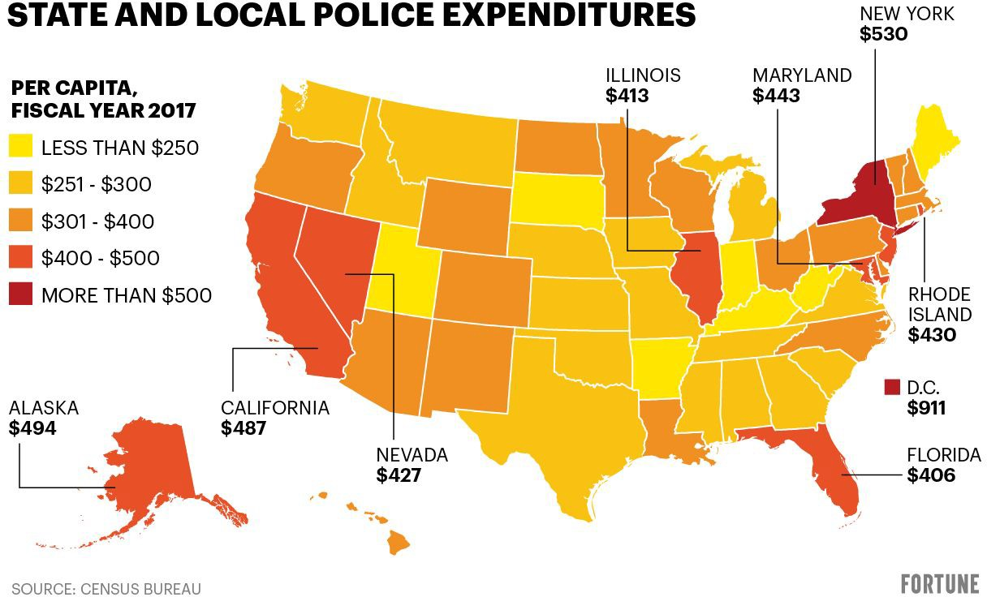

TABLE 20: Full-Time Law Enforcement Staff by State, 2018. SOURCE: Criminal Justice Information Services Division, 2018
State | Total law employees | Total officers |  | Total civilians |  | No. of agencies | 2018  estimated population
 |  | Men | Women | Men | Women |  |  | Polic e Offic ers/ Capit  a
WASHINGTON DC | 5,145 | 3,417 | 976 | 320 | 432 | 3 | 702,455 | 160
NEW JERSEY | 40,847 | 28,659 | 3,158 | 3,521 | 5,509 | 531 | 8,638,529 | 272
NEW YORK | 84,204 | 53,072 | 9,255 | 7,860 | 14,017 | 412 | 18,697,787 | 300
LOUISIANA | 18,554 | 10,990 | 2,970 | 1,592 | 3,002 | 185 | 4,200,142 | 301
ILLINOIS | 36,749 | 22,164 | 4,580 | 5,343 | 4,662 | 371 | 8,323,221 | 311
WYOMING | 2,323 | 1,358 | 132 | 292 | 541 | 56 | 519,563 | 349
NEW MEXICO | 3,877 | 2,433 | 277 | 433 | 734 | 100 | 994,639 | 367
GEORGIA | 36,833 | 22,481 | 4,769 | 3,048 | 6,535 | 527 | 10,012,759 | 367
PENNSYLVANIA | 29,181 | 22,863 | 2,642 | 1,282 | 2,394 | 1,074 | 9,791,899 | 384
MASSACHUSETTS | 20,340 | 15,220 | 1,497 | 1,505 | 2,118 | 306 | 6,428,834 | 385
MISSISSIPPI | 4,240 | 2,413 | 287 | 595 | 945 | 62 | 1,048,379 | 388
TENNESSEE | 27,737 | 15,610 | 1,753 | 4,876 | 5,498 | 454 | 6,766,324 | 390
MARYLAND | 19,916 | 13,353 | 2,057 | 1,620 | 2,886 | 149 | 6,041,598 | 392
KANSAS | 8,992 | 5,887 | 688 | 819 | 1,598 | 305 | 2,578,157 | 392
S. CAROLINA | 15,215 | 9,999 | 1,554 | 1,292 | 2,370 | 335 | 4,651,913 | 403
MISSOURI | 20,226 | 12,943 | 1,485 | 2,301 | 3,497 | 503 | 5,980,758 | 415
DELAWARE | 3,305 | 2,043 | 272 | 377 | 613 | 55 | 964,931 | 417
RHODE ISLAND | 3,113 | 2,296 | 198 | 245 | 374 | 49 | 1,057,315 | 424
N. DAKOTA | 2,477 | 1,562 | 214 | 251 | 450 | 106 | 759,138 | 427
CALIFORNIA | 120,041 | 68,663 | 10,478 | 15,339 | 25,561 | 465 | 33,867,039 | 428
N. CAROLINA | 34,100 | 21,179 | 2,825 | 4,565 | 5,531 | 520 | 10,377,256 | 432
VERMONT | 1,815 | 1,242 | 150 | 139 | 284 | 86 | 606,587 | 436
VIRGINIA | 24,272 | 16,719 | 2,539 | 1,344 | 3,670 | 284 | 8,516,800 | 442
OKLAHOMA | 13,016 | 8,107 | 786 | 1,616 | 2,507 | 414 | 3,938,268 | 443
ARKANSAS | 10,628 | 6,123 | 620 | 1,533 | 2,352 | 303 | 3,009,746 | 446
ALABAMA | 15,855 | 9,763 | 898 | 2,000 | 3,194 | 376 | 4,764,354 | 447
WISCONSIN | 18,013 | 11,028 | 1,676 | 2,260 | 3,049 | 413 | 5,708,284 | 449

NEW HAMPSHIRE | 3,689 | 2,572 | 266 | 254 | 597 | 174 | 1,279,586 | 451
INDIANA | 12,513 | 8,208 | 1,141 | 1,322 | 1,842 | 121 | 4,230,746 | 453
FLORIDA | 68,605 | 36,327 | 6,553 | 9,951 | 15,774 | 333 | 19,436,120 | 453
OHIO | 19,868 | 13,323 | 1,653 | 1,847 | 3,045 | 287 | 6,795,599 | 454
COLORADO | 18,510 | 10,791 | 1,721 | 2,181 | 3,817 | 239 | 5,690,128 | 455
CONNECTICUT | 9,283 | 6,970 | 822 | 596 | 895 | 106 | 3,572,665 | 459
TEXAS | 70,186 | 38,960 | 5,897 | 10,239 | 15,090 | 570 | 20,609,733 | 459
NEVADA | 9,110 | 5,588 | 685 | 847 | 1,990 | 50 | 3,034,392 | 484
S. DAKOTA | 3,008 | 1,615 | 156 | 585 | 652 | 129 | 862,436 | 487
HAWAII | 3,624 | 2,544 | 300 | 243 | 537 | 4 | 1,420,491 | 499
KENTUCKY | 9,588 | 6,897 | 489 | 869 | 1,333 | 273 | 3,691,938 | 500
WEST VIRGINIA | 4,538 | 3,463 | 129 | 359 | 587 | 291 | 1,795,624 | 500
NEBRASKA | 5,398 | 3,370 | 427 | 559 | 1,042 | 162 | 1,912,427 | 504
MICHIGAN | 23,991 | 15,076 | 2,153 | 3,559 | 3,203 | 609 | 9,334,869 | 542
MONTANA | 2,902 | 1,706 | 133 | 472 | 591 | 100 | 1,017,708 | 553
ARIZONA | 22,428 | 11,357 | 1,399 | 4,417 | 5,255 | 114 | 7,170,315 | 562
MINNESOTA | 15,264 | 8,755 | 1,172 | 2,429 | 2,908 | 396 | 5,605,723 | 565
MAINE | 2,932 | 2,162 | 187 | 214 | 369 | 133 | 1,331,125 | 567
ALASKA | 1,985 | 1,162 | 124 | 263 | 436 | 38 | 737,438 | 573
IOWA | 7,530 | 4,350 | 366 | 1,213 | 1,601 | 219 | 2,710,078 | 575
IDAHO | 5,567 | 2,689 | 205 | 1,134 | 1,539 | 108 | 1,751,570 | 605
UTAH | 7,235 | 4,728 | 378 | 893 | 1,236 | 134 | 3,146,133 | 616
OREGON | 10,664 | 5,856 | 697 | 1,757 | 2,354 | 206 | 4,111,065 | 627
WASHINGTON | 15,873 | 9,754 | 1,066 | 2,071 | 2,982 | 257 | 7,507,712 | 694
Avg.
Per State
TOTAL | 975,305 | 599,810 | 1,575,115 | 114,642 | 173,998 | 288,640 | 287,702,296 | 451

Racial Disparities in Juvenile Incarceration in Maryland

According to the Department of Justice, Black youth are five times more likely to be detained and ultimately incarcerated than white youth. One of the most disturbing statistics uncovered by the Task Force for Reconciliation and Equity is that Maryland leads the United States in the increase of Black/white racial disparity in youth incarceration, since the 21st century began. Only five states, Maryland, Montana, Connecticut, Delaware and Wisconsin doubled their incarceration of juveniles during the past 20 years. This was during a period when nearly 25% of states lowered their rate of incarceration of juveniles. Currently, there are 610 incarcerated juveniles in Maryland institutions. See Figure 26. This figure was significantly reduced in late April 2020 because of the Coronavirus outbreak.

FIGURE 26: Change in Black/White Racial Disparity in Youth Incarceration, 2001 vs. 2015
SOURCE: The Sentencing Project, 2018
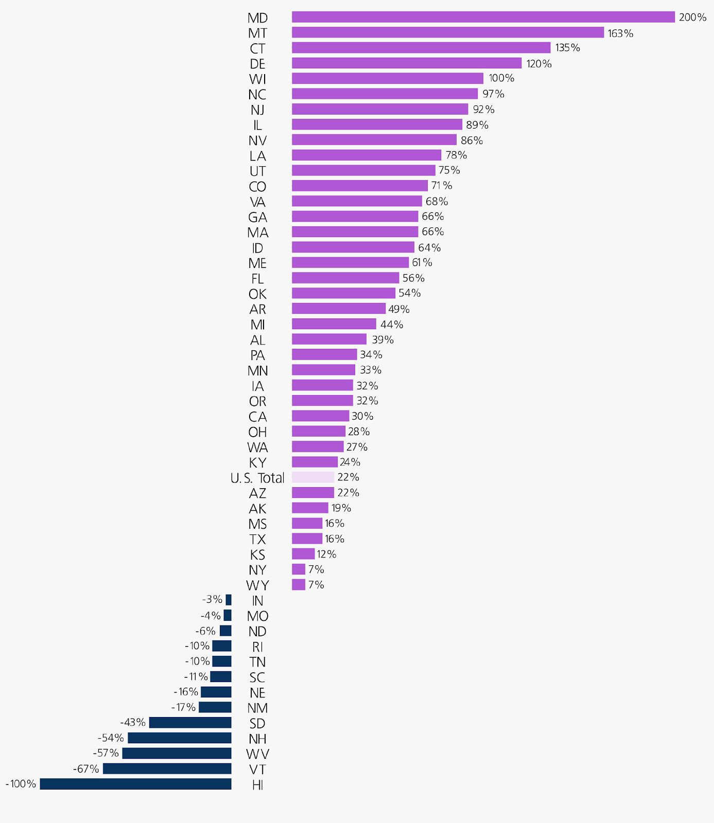

Figure 27: Who is in Maryland’s Prisons? Source: Prison Policy Institute, 2018

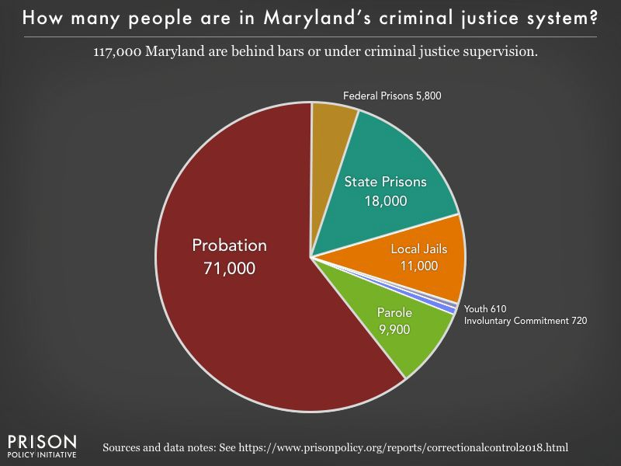

Maryland released 200 youths from detention facilities because of health concerns. As a result, the percentage of juveniles who had misdemeanor charges dropped from 44% to 25% and the percentage of Black youth detained dropped from 77% to 58%.²⁵ African American youth (those under 18) like their adult counterparts, are disproportionally represented in detention facilities in Maryland. The state of Maryland has the highest

25
https://www.baltimoresun.com/coronavirus/bs-md-pol-juvenile-release-coronavirus-20200427-4mjlk5pawnbpnafusvm7a7b7g4
-story.html

incarceration rate in the nation of Black men aged 18 to 24 (emerging adults), while the second-highest incarceration rate for young black men is in Mississippi.²⁶

Figure 28: Sentencing of Emerging Adults (under the age of 25) by Race in Maryland and Three Other States. Source: Justice Policy Institute, 2019

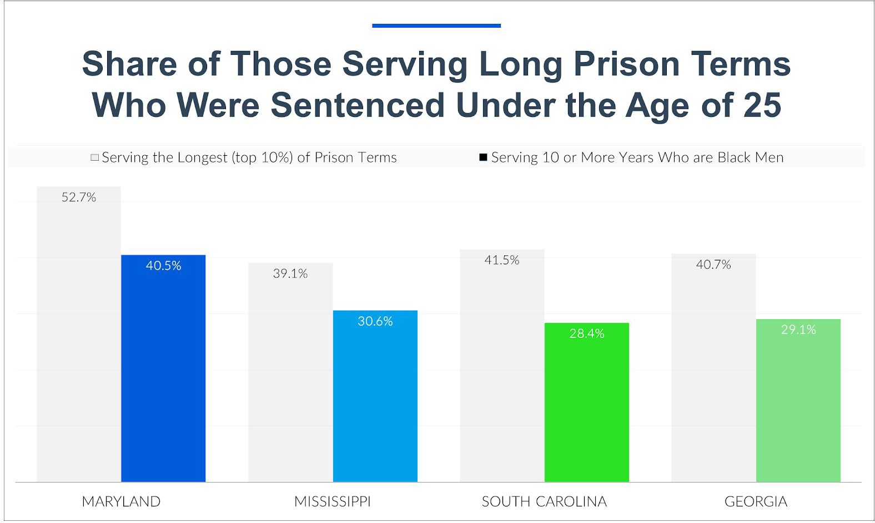

INCARCERATION RATES BY RACE IN MARYLAND

Like other states, Maryland over-incarcerates Black people, be they young, old, male or female. While the history of mass incarceration of African Americans has been well-documented in Michelle Alexander’s 2012 bestselling book, The New Jim Crow: Mass Incarceration in the Age of Colorblindness, Maryland’s incarceration rates of Black people is extraordinarily high. African Americans comprise 29% of the population of

26
https://www.wusa9.com/article/news/local/maryland/maryland-leads-the-nation-with-incarcerating-black/65-072db101-95f1-4a 16-b6ff-79a839e7d184

Maryland but 68% of the prison population, higher than any other ethnic group in the state. Figures 29 and 30 show the intersectionality of race, gender and income in the incarceration of adults in Maryland and the United States. In any analysis of mass incarceration all of these factors should be studied in order to understand why people are in prison, but too often a single factor is cited which gives a distorted picture of the incarcerated.

Figure 29: Racial and Ethnic Disparities in Maryland Prisons, compiled from 2010 Census Data
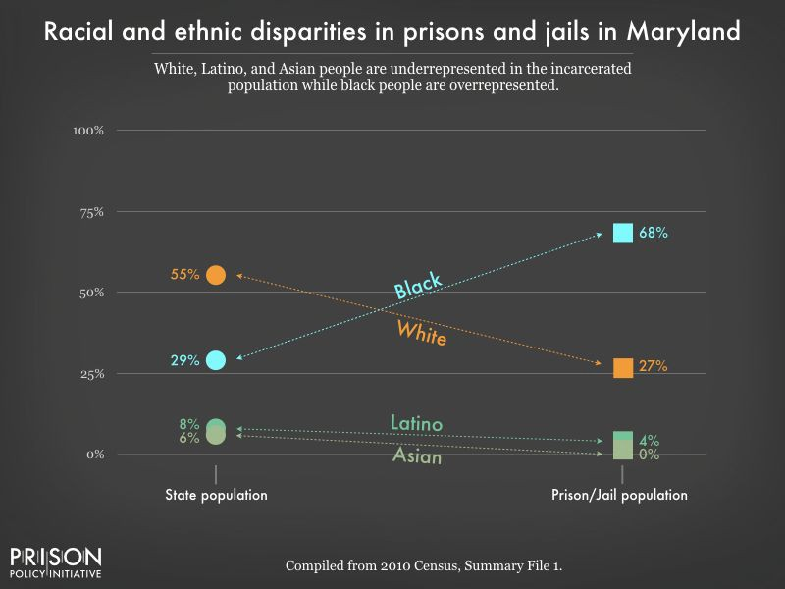

Figure 30: Relationship Between Income, Gender and Race of the Incarcerated in Prison

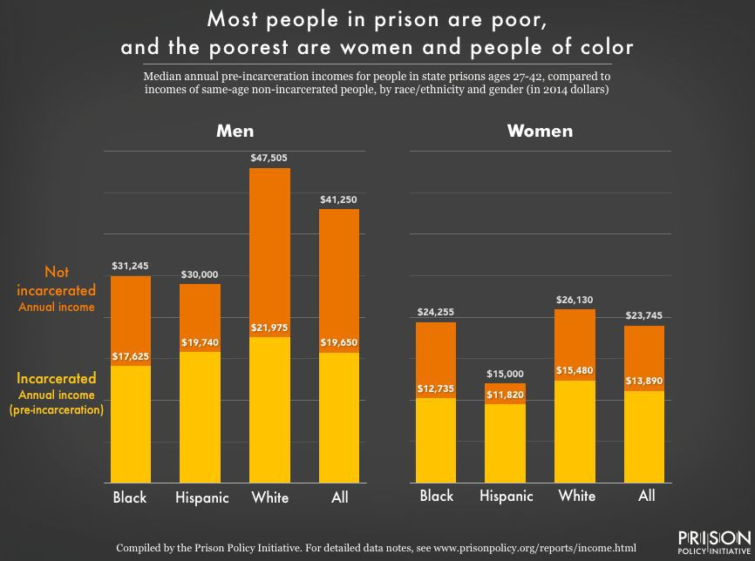

RECOMMENDATIONS

Our Recommendations:

- Create a Citizens’ Investigative Review Board (CIRB), a state-wide investigative body that will be composed of experienced investigators with strong investigative backgrounds, deep understanding of anti-racism-anti-oppression / racial justice principles and supervised by good standing citizens: two per county. These citizens will have to go through a strong vetting clearance and basic law enforcement training, as well as anti-racism/anti-oppression / racial equity trainings. This body will handle complaints from citizens on police misconduct, as well as EEO and corruption issues reported by police officers, and offer whistle blower protections for them in doing so. This body should be led by a States Attorney who will be appointed to the position and serve a term long enough to guarantee impartiality and non-political interferences in the service of this body or those leading and participating as members.

Require all 19,916 individuals working in the 149 law enforcement agencies (LEAs) in
Maryland to reside within 25 miles of the district where they are employed. This includes citizens working for the LEAs. This is a policy adopted by the city of Pittsburgh as well as 15 of the largest police departments in the U.S. While research is divided if residency

requirements are effective in reducing police violence in the districts they serve, there is more evidence that it does.²⁷

Appendix A

Reconciliation and Equity Virtual Hearing Report

Submitted by
The Reconciliation and Equity Task Force

September 30, 2020

²⁷ https://www.governing.com/topics/public-justice-safety/gov-rope-community-policing-elgin-rockford.html

Page 9.

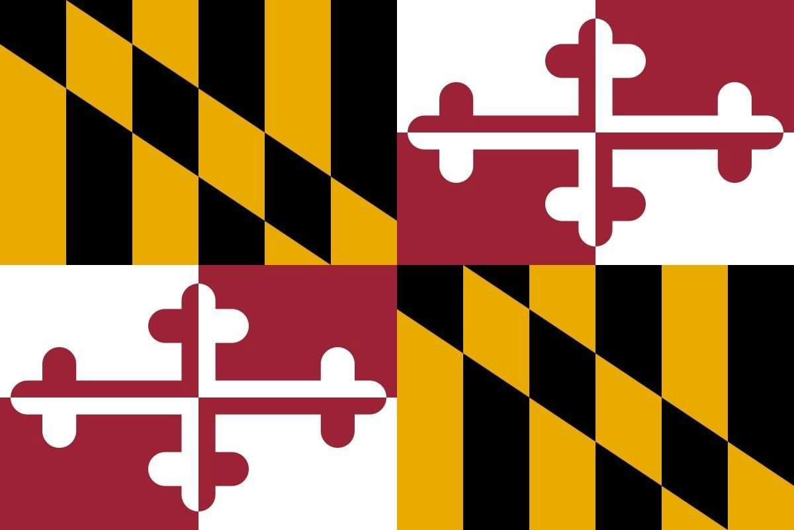

Table of Contents
Background 3
Reconciliation and Equity Virtual Hearing 4
Participants 4
Maryland Counties Represented 5
Topics Discussed 5
Summary of Comments by County 6
Allegheny County 6
Anne Arundel County 6
Baltimore City 6
Baltimore County 6
Calvert County 6
Charles County 7
Howard County 7
Harford County 7
Prince Georges 7
Somerset County 7
St Mary’s County 7
Worcester County 7
Recommendations 8
A Closing Word 8
Walter Kirkland - Reconciliation and Equity Virtual Hearing Host/Moderator 8
Senator Nathan Pulliam – Reconciliation and Equity Virtual Hearing Chair 8

Page 2.

Background

In 2018 the Maryland General Assembly passed Bill 350 entitled Morgan State University
- Task Force on Reconciliation and Equity. The bill was sponsored by Senator Nathan-Pulliam, Education, Health, and Environmental Affairs Committee and co-sponsored by Senators Joanne Benson, James Brochin, Joan Carter Conway, Ulysses Currie, Brian Feldman, William Ferguson and Guy Guzzone.
The bill required the Institute for Urban Research at Morgan State University (MSU) to convene a task force to explore issues of reconciliation, inclusionary justice, and racial equity that includes specified stakeholders. The task force must consult with specified State agencies and may consult with other units of State or local government, as appropriate. On request of the task force, a unit of State government must provide information or staff support in a timely manner or designate a representative to serve as a member of the task force or attend a meeting or hearing of the task force.
The purpose of the task force was to foster reconciliation and inclusionary justice and work toward achieving racial equity by (1) increasing awareness through public discussions about the nature, extent, causes, and consequences of racial inequities; (2) involving individuals and public and private entities, including African American and other minority groups, in every sector throughout the State in a collective process; (3) fostering racial equity through recognition, understanding, adjustment, compromise, and repair; and (4) recommending strategies, changes, and actions in institutions, policies, and laws to eliminate systemic racism and promote equity, access, and opportunity that can lead to healing and foster reconciliation. Specifically, the bill required the task force to:
- hold hearings at various locations throughout the State and receive testimony, as specified.
- study
  - the nature of racism, sexism in the experience of racial inequities, and institutional bias throughout the State;
  - manifestations of institutional and structural racism;
  - the impact of institutional and structural racism, as specified;
  - past and ongoing efforts to promote human rights and social and inclusionary justice; and
  - best practices throughout the United States regarding policies, laws, and systems designed to eliminate institutional and structural racism and sexism and foster repair for those impacted;

- identify the criteria to be used in monitoring and evaluating the implementation of the strategies and changes in institutions, policies, and laws recommended by the task force;
- make recommendations regarding strategies, changes, and actions in State institutions, policies, and laws to improve race relations, eliminate institutional and structural racism and gender inequities, and support repair and justice, including specified measures; and
- monitor and evaluate the implementation of the recommended strategies and changes in State institutions, policies, and laws using the criteria developed by the task force.
Page 3.

Hearings were initially planned for the early part of 2020. However, because of the emergence of the COVID-19 Pandemic and the resulting disruption it brought to Maryland and the entire country, no in-person hearings were possible. As a result, a virtual hearing was held instead on August 28th. Members of the state government and public citizens of the state of Maryland as required, were invited to participate. This report describes the process, findings obtained from the virtual hearing.

Reconciliation and Equity Virtual Hearing
Participants

Approximately 35 individuals representing public and private organizations, including state government from across the state of Maryland participated in the Reconciliation and Equity Virtual Hearing. The meeting was chaired by Senator Shirley Nathan-Pulliam and Co-Chaired by Mr. Walter Kirkland. Other participants include the following individuals.

- Senator Shirley Nathan-Pulliam, Retired**
- Senator Malcolm Augustine - Prince George's County, 47th Legislative District
- Hon. Tim Adams – Mayor, Bowie, MD
- Del. Ben Brooks – Baltimore County 10th Legislative District
- Sen. Obie Patterson – Prince Georges County
- Del Edith Patterson – Charles County
- Deron E. Tross - Charles County
- Bobbe Frasier - Retired Division Chief at the MD Dept. of Health., Baltimore County resident
- Gay Green-Carden – Resident Prince Georges County resident
- Nasrin Rahman - Cofounder of Hajar’s hope women center for homeless women n children started in 2005, Principal of ARSs, Vice President of Baltimore County Muslim Council, and Commissioner of Human Relations, active member of Islamic society of Baltimore.
- Carmen B. Jackson, Allegany County NAACP President, Retired from Frostburg State University as Assistant to the Vice President of Student and Education Services, Amerita
- Laken Oyedokun – Information Technology professional, Baltimore County resident
- Jim Thornton - President of Harford
County Caucus of African American Leaders
- Jesus Perez – Baltimore City
- Jim Thomas** – Ret IT Professional DHMH, Howard County resident
*Members of the Reconciliation and Equity Task Force
** Subcommittee Members

Page 4.

Stephanie Klapper, Maryland Citizens' Health
Initiative
- Elaine Zammett – Office of Sen. Malcolm Augustine, Prince Georges County
- Fredette West – African American Health Alliance, Calvert County resident
- Dr. Yolanda Ogbolu – Howard County resident
- Dr. John Hudgins* - Coppin State University
- Laurie Brittingham - Vice President NAACP Worcester County
- Rev. Charles Bagley - President of Somerset County NAACP
- Rev. Heath – Somerset County
- Dyotha Sweat – President, Charles County NAACP
- Pamela Cousins – Talbert County Board of
Education
- Miguel Rodriguez* – Baltimore City Police Department
- Rev. Florence Ledyard* – St. Bartholomew’s
Episcopal Priest
- Ed Burrows – Prince Georges County School Board
- Dr. Charlotte Wood** – Coppin State
University
- Michael Kent – Calvert County NAACP
- Ola Ojewumi – Prince Georges County
- Inez Claggett – Prince Georges County
- Alonzo Gaskin – St. Mary’s County
- Walter Kirkland – Hearing Host/Moderator
- Ivor Smith – St. Mary’s Count

Maryland Counties Represented

More than half (54% or 13 of 24) of Maryland Counties participated in the virtual hearing on reconciliation and equity. These include:
  - Allegheny County
  - Anne Arundel County
  - Baltimore County
  - Baltimore City
  - Calvert County
  - Charles County
  - Howard County
  - Harford County
  - Prince Georges
  - Somerset County
  - St Mary’s County
  - Talbert County
  - Worcester County

Topics Discussed

Hearing participants discussed a wide range of experiences relating to bias, racial discrimination, racism, racial profiling occurring at several Maryland state agencies and organizational settings including healthcare, educational institutions, Law enforcement and Criminal Justice and voter suppression. Generally, the comments could be divided into the following 4 categories: Jobs/Employment. Health, education, criminal justice and one person spoke about voter suppression issues.
Participants detailed the wide-ranging effects of these experiences that include fear, intimidation, job loss, reprisals, mental health challenges, stress, stroke, lost wages and other economic, physical and psychological hardships for the people experiencing these issues and at times also for other family members involved.

Page 5.

Summary of Comments by County
Allegheny County
  - Significant confusion among residents about voting
  - There have been multiple changes in the places to vote without adequate notification
  - Misinformation/incorrect and misleading information has been provided to residents
  - The informational website is generally not helpful
  - Unusual charges being imposed for voter instructional materials
  - General lack of assistance for underserved populations
Anne Arundel County
  - Racial Graffiti at Salisbury University
  - Slow and insensitive university response
Baltimore City
  - Significant discrimination of HBCU’s by the state Department of education
  - Latinx and Latinx individuals are significantly underrepresented in Baltimore city jobs.
  - This includes the Baltimore city police force.
  - Also, significant discrimination in promotion and hiring among Latinxs statewide
Baltimore County
  - Documented and verified multiple instances of excessive denial of promotions and raises among African American males at the MD Dept of Health and Mental Hygiene.
  - Lack of accountability for these issues among leadership at the state health department
  - No improvement plan or sensitivity training implemented at state department of health
  - In response, the department acknowledged and accepted most of the recommended reforms. Including hiring a diversity and inclusion officer. However, this person is inadequately funded and supported. The office focuses primarily on EEOC issues and is not equipped to assess or address issues of equity and inclusion in hiring or promotion
  - Extensive history of discrimination in MD Military Department
  - Ret. Cols African American K. McNeil, Q. Banks and numerous minority staffers suffered and are still being subjected to Denial of EEO and discrimination
  - Also ongoing at MEMA with skeleton IT Staff
  - Discriminatory hiring and firing practices at MEMA and Dept of Planning
  - Similar problems at the Department of Education
  - Significant discrimination against Muslim wearing traditional attire
Calvert County
  - COMAR 13A.01.06, Educational Equity Policy requires every county to have an Educational Equity Policy. Need to document evidence of compliance with this law.
  - Also, school boards to adopt an Anti-Racism Policy as part of the Equity policy.
  - Racial graffiti painted on Calvert County High School walls
  - Need to strengthen hate crime laws
  - When stopping African Americans county police officers routinely calling for drug sniffing dogs

  - Police officers also routinely asking passengers for ID without cause

Charles County
  - Significant disparities in elementary school expulsions between African American and White students
  - This is creating a two-tiered educational system in the county
  - Police force does not mirror the racial makeup of the county
  - Police reforms generally not institutes despite having a black police chief
Howard County
  - Significant recent increase in racism in the Howard County school system over the last 2- 3 years
  - Significant increase in microaggressions
  - Police profiling of students of color
Harford County
  - County school system desegregated more than a decade after (1965) Brown vs Board of Education
  - Significant racial disparities between teaching staff and students
  - 80% (4 of 5) African American female assistant principals recently demoted
  - Unusual criteria and process used to make decisions about promotion/demotion
Prince Georges
  - Significant experiences of discrimination/racism in the context of healthcare in the county
  - People of color/First World People judged by clinicians to be less reliable, therefore treated dismissively
Somerset County
  - Reforms are needed in prison operations and public safety in addition to police reforms
  - A lot of intimidation of minority members of the board of Education
  - Minority members of the board of education live in fear of reprisals
  - Appears to be a concerted effort to reduce the number of First World People and increase the number of Whites on the board of education
St Mary’s County
  - Growing number of homeless individuals in the county
  - Significant increase in the number of families needing assistance for necessities
  - This is increasing mental health issues and the need for mental health services in the county.
Worcester County
  - Increasing problem with housing affordability especially among African Americans
  - This is causing a significant housing segregation issue in the county
  - This is fueled by the lack of jobs in the county. Many seasonal jobs in Ocean City
  - Significant racial disparities exist in criminal sentencing between white and African American offenders

Page 7.

Recommendations

Based on the comments and discussions of the participants of the Reconciliation and Equity Virtual Hearing, the Task Force on Reconciliation and Equity offers the following recommendations:
  - Make sure all elementary and high school principals are committed to promoting equitable learning environments for all students
  - Work to remove those principals who are not willing/able to support #1
  - Incorporate implicit bias training to all levels of the educational teaching and administrative staff
  - Embed antiracism and equity principles into the state educational curricula
  - Hire state educational liaisons who can audit the implementation of equity and antiracism reforms
  - Audit student disciplinary procedures by race annually
  - Audit hiring/promotion among teaching and administrative staff by race
  - Governor and legislators need to honor the lawsuit won by HBCU’s
  - Enhance Healthcare professional training on Diversity, Inclusion, Equity and Implicit Bias
  - Ensure annual Diversity and Inclusion bias/racism audits and accountability at MD Department of Health
  - Ensure health and safety of detainees in the State department of Corrections to reduce community transmission of health issues and concerns.

A Closing Word

Walter Kirkland - Reconciliation and Equity Virtual Hearing Host/Moderator

It was both disheartening and invigorating to participate in this important hearing. While it was disheartening to hear the many incidents of racism and inequitable treatment people of color are experiencing in Maryland in 2020, it was also invigorating to see the dedication and hear the commitment of all involved to meeting these issues head on. There seems to be a difference afoot. It is no longer just African Americans fighting this cause. It is now African Americans, Latinxs and White Americans working together to fight this plague. It is no longer just about reparations, but also about recovery for all. Be encouraged!

Senator Nathan Pulliam – Reconciliation and Equity Virtual Hearing Chair

It is the goal of SB350 and the hope of the Task Force on reconciliation and equity that this hearing will broaden the perspectives of legislators regarding issues associated with race and equity in Maryland. We hope that this information particularly informs those who were not able to participate in the hearing. Thank you very much for coming and letting your voices be heard. Thank you especially for those representatives from counties that do not normally participate in these types of events. Additionally, to those legislators listed above who attended virtually, I
would like to give a special note of thanks to Del. Steven Johnson from Harford County, Del. Wanika Fisher from Prince Georges County, Sen. Antonio Hayes from Baltimore City, Del. Mary Beth Carozza from Somerset, Wicomico & Worcester Counties, Sen. John D. (Jack) Bailey from Calvert & St. Mary's Counties and Del. Michael Jackson from Prince Georges County for their tireless efforts to ensure the voices of concerned citizens were heard and for helping to ensure this hearing was a success. I wish you all the best as we move forward together.

Data analysis and report produced by The Greystone Group, Inc.
FMI Contact - Chris Gibbons, MD, MPH - 202.813.9448

